–

Organization Name

Software Design

Document

Muath Abdul Kareem 21210016

Billing and Invoice System   
*Revision 1.0*

*Date: (08/09/2025)*

# Revision History

|  |  |  |  |
| --- | --- | --- | --- |
| **Version** | **Name** | **Reason For Changes** | **Date** |
| *1.0* | *Sue Dillehay*  *David Kurth*  *Jon Fletcher* | *Initial Revision* | *8/19/2022* |
|  |  |  |  |

# 

# Approved By

Approvals should be obtained for project manager, and all developers working on the project.

|  |  |  |  |
| --- | --- | --- | --- |
| **Name** | **Signature** | **Department** | **Date** |
| Bill Currie |  | BP-IT-Development |  |
|  |  |  |  |

Contents

Revision History 2

Approved By 2

1. Introduction 7

1.1 Overview 7

1.2 Purpose 7

1.3 Project Scope 7

1.4 References 7

1.5 Target Audience 7

1.6 List of Abbreviation 7

2. Overall Description 8

2.1 Problem Statement 8

2.2 Proposed Solution 8

2.2.1 Project Idea 8

2.2.2 Stakeholders 8

2.2.3 Actors 8

2.3 Areas of Risk 8

2.4 Product Overview 8

2.4.1 Functional requirement (functional requirement per actor) 8

2.4.2 Nonfunctional Requirement (Quality Attributes) 9

2.4.2.1 Reliability 9

2.4.2.2 Availability 9

2.4.2.3 Security 9

2.4.2.4 Maintainability 9

2.4.2.5 Portability 9

2.5 System Analysis 9

2.5.1 Component Diagram 9

2.5.2 Class Diagram 9

2.5.3 Use case Diagrams (Per functionality) 9

2.5.4 Activity Diagram 9

Text + figures 9

3. Overall Design 10

3.1 Design Overview 10

3.1.1 Design Techniques Comparison 10

3.1.2 Design Tools 10

3.1.2.1 The preferable Design Tool and Technique 10

3.2 High-Level Design (HLD) 10

3.2.1 Sitemap 10

3.2.2 Wireframes 10

3.2.3 Mockups 10

3.3 Low Level Design (LLD) 10

3.3.1 ERD 10

4. Overall Development 11

4.1 Development Overview 11

4.1.1 Development Techniques Comparison 11

4.1.2 Development Tools 11

4.1.2.1 The preferable Development Tool and Technique 11

4.2 Software Development Methodology 11

4.3 Overall Design and Development Justification 11

4.4 Development Plan Presentation 12

4.4.1 Peer review feedback 12

4.4.2 Interpret the peer review feedback 12

4.4.3 Identify and evaluate new opportunities 12

4.5 Application Development 12

4.5.1 Database 12

4.5.2 Screenshots of your application 12

5. Testing 13

5.1 Testing plan 13

5.2 Performance review 13

5.3 Overall Business Application review 13

5.3.1 Critical review for all application development phases 13

5.3.2 Application evaluation and future development 14

6. Implementation and support 14

Table of Tables

Table 1 Advantages and Disadvantages of types of each design tool 10

Table 2 Advantages and Disadvantages of types of each development tool 11

Table 3 Test cases plan table 13

Table of Figures

[Figure 1 A use case to supply chain members relations 9](https://hatuniversity-my.sharepoint.com/personal/lina_hammad_htu_edu_jo/Documents/Courses/HTU%20courses/Application%20Development/2022%20Spring/Slides/SDD%20-%20my%20vesrion%20.docx#_Toc104153686)

[Figure 2 a use case to enterprise architect user guide 9](https://hatuniversity-my.sharepoint.com/personal/lina_hammad_htu_edu_jo/Documents/Courses/HTU%20courses/Application%20Development/2022%20Spring/Slides/SDD%20-%20my%20vesrion%20.docx#_Toc104153687)

# Introduction

## Overview

Provide an overview of this document and its organization.

A Software Design Document, or SDD, is a formal, structured description of how developers will build a software system to satisfy specified requirements. It is the "bridge" between the requirements analysis phase and the implementation phase of the Software Development Life Cycle (SDLC).

The SDD will provide detailed descriptions of the architecture, components, interfaces, and data structures of the software system. Often the SDD will describe both high-level design (what parts constitute the overall structure of the system, modules, and how they will relate to each other) and detailed design (the project-level logic, algorithms, and database schemas).

The important uses of an SDD are to:

Provide the developer with a blueprint for implementation.

Provide all stakeholders with a clear understanding of the system design.

Document the decisions made in the design phase and alleviate ambiguity.

Provide a source of reference for ongoing maintenance and enhancement of the software system.

## Purpose

Identify the purpose of this SDD and its intended audience. (e.g., “This software design document describes the architecture and system design of XX. ….”).

This Software Design Document (SDD) contains a detailed plan for designing the Billing & Invoicing System. The design takes the requirements contained in the analysis and creates a structured technical design to build the Billing & Invoicing System, as well as go through implementation, testing, and deploying the system.

The SDD describes the design of the architecture, data, interfaces, and components of the system. It is intended to give the stakeholders a clear understanding of how the system will work, and how it will be put together. The SDD includes visual models, UML diagrams, ERD diagrams, class diagrams, component diagrams, activity diagrams, etc. to help show the structure and behavior of the system.

In addition, the SDD will document data flow, module interactions, and rationale about why major design decisions were made. By keeping documentation like the SDD, the project team can verify alignment of functional requirements, non-functional requirements, and final product.

This document will be used by:

Developers - as a guide to build each module in the system.

Testers - to check that all functionalities are correctly implemented.

Stakeholders - to see how their requirements are being achieved in design finalization.

## Project Scope

Provide a short description of the software being specified and its purpose, including relevant benefits, objectives, and goals. Relate the software to corporate goals or business strategies. If a separate vision and scope document is available, refer to it rather than duplicating its contents here.

This project is to develop a Billing and Invoicing System for a telecom provider. The system will assist in generating charges for calling, SMS and internet data, applying taxes and discounts, and printing (saving) monthly invoices as PDFs. It will also store billing history (for each user) and include some basic administration functions like generating reports, and mock payment processing. The system will support basic user accounts and logins only. The overall system was intended primarily to be a web-based solution and will not include an actual payment gateway or integration with real telecom networks; these aspects will be represented as simulated activities to show how the system would function in real life.

The ultimate target of this project is to develop simple and accurate billing system that assists telecommunication providers with more accurate customer charges. By automating billing processes, the system will minimize manual work, reduce the risk of calculation issues, and enhance the overall experience for both the consumer and company. It will also allow Admins to track billing reports, and a better comprehensive overview of financial records.

## References

This section is optional

List any other documents or Web addresses to which this SDD refers. These may include user interface style guides, contracts, standards, system requirements specifications, use case documents, or a vision and scope document. Provide enough information so that the reader could access a copy of each reference, including title, author, version number, date, and source or location.

## Target Audience

This section is optional

Describe the different types of reader that the document is intended for, such as developers, project managers, marketing staff, users, testers, and documentation writers. Describe what the rest of this SRS contains and how it is organized. Suggest a sequence for reading the document, beginning with the overview sections and proceeding through the sections that are most pertinent to each reader type.

## List of Abbreviation

Provide definitions of all terms, acronyms, and abbreviations that might exist to properly interpret the SDD. These definitions should be items used in the SDD that are most likely not known to the audience.

This Software Design Document (SDD) uses a number of technical terms, acronyms, and abbreviations that may not be understood by all readers. SDD stands for Software Design Document which describes the architecture of, components of and decisions made during the design of the system. SDLC stands for Software Development Life Cycle, which is the process of planning, developing, deploying, and maintaining the software in a structured manner. UI (User Interface) and UX (User Experience) are used to denote the visual components the user interacts with, and the measure of satisfaction for using the system, respectively. ERD (Entity Relationship Diagram) is a diagram that represents the structure of a database, and UML (Unified Modeling Language) is the standard notation for drawing diagrams to describe software systems. An invoice is a printed document that describes the transaction that occurs between two parties and typically includes description of products or services the price of products or services, and terms of payment. In the case of an invoice, the transaction occurs during a defined billing cycle, such as monthly or quarterly. The payment gateway is the service that authorizes transactions made online and allows the transaction to be processed.

Authentication is the process of confirming a user's identity, while authorization defines the user's ability to act. Database schema refers to how data is structured, including tables, attributes, and relationships. API means application programming interface, which is a set of protocols for connecting software components. Financial terms, such as late fee (additional charge to overdue payment) and discount (decrease in total owed), are found in this document. Every payment is assigned a transaction ID for tracking payments. The system will also include a report generation function to report summaries of data to be analyzed and recorded.

# Overall Description

## Problem Statement

Discuss and produce a problem definition statement to highlight and describe the issues that need to be addressed. You need clearly to specify the problem statement and user and system requirement.

Problem Statement

Numerous small to medium-sized companies continue to manually bill or use outdated billing processes that are prone to errors, delays, and inefficiencies. Systems in use today reside somewhere in between automation and periodical billing processes lacking the ability to automate any part of generating invoices or billing customers and calculating their charges, taxes and discounts or connected to a payments 'gateway'. As a consequence of this inefficient process, staff will spend much time doing repetitive tasks, customers will wait for invoices and tracking payments will be more difficult. Additionally, without centralized reporting or ability to store past billing activities, it will be more difficult for organizations to hold adequate records to maintain their financial position or analyze performance.

There exists a need for a central and automated billing and invoicing system that could minimize human errors, assist with a more timely billing cycle, allow users and administrators real-time access to transaction costs to billing for processes and create a centralized storage for billing fee history.

User Requirements

The new system should have the following user needs:

1. Easy Authentication - Users should have a secure, easy way to log in to the system.

2. View and Download Invoices - Customers should have the ability to view, download and print invoices, at any time.

3. Online Payment Capabilities - Users should be able to pay using a secure online payment gateway.

4. Transaction History - Customers should have the ability to access previous billing history and payment receipts

5. Alerts and Notifications - Users should receive alerts for due payments, successful payments, and failed transactions.

6. Responsive Design - The system should be usable across devices regardless of size (desktop, tablet, mobile).

System Requirements

Functional Requirements:

1. Automatically calculate charges for calls, data, and SMS usage.
2. Generate and store invoices in PDF format.
3. Apply taxes, discounts, and late fees automatically.
4. Integrate with a secure payment gateway.
5. Maintain a billing history database for each user.
6. Generate financial and usage reports for administrative staff.

Non-Functional Requirements

Basic Security – User accounts must have username and password authentication.

System Availability – The system shall be available during business hours (e.g., 8 AM – 8 PM).

Basic Performance – Pages and invoices shall take a reasonable time to load (e.g., 3–5 seconds).

Ease of Use – The interface shall be crisp and easy for new users to navigate.

Basic Scalability – The system should be able to handle a small increase in users (e.g. up to 200 users actively using the application) without any noticeable performance degradation.

## Proposed Solution

## Project Idea

Research and consider possible solutions by conducting a system analysis process.

The billing process few organizations undergo today is time-consuming, error prone, and does not utilize automation. Staff will have to calculate the charges, will have to invoice the customer, and will have to follow-up on payments, all of which create room for delays or mistakes. Furthermore, there is usually no simple way for customers to check for invoices, nor download multiple invoices. There also isn't always an online payment method, or if there happens to be one, it is not seamless. The organizations will have to adopt a centralized, automated Billing & Invoicing System that calculates charges, taxes or discounts, invoices in PDF format, and accepts online payments.

We explored possible solutions and based on our findings, there are three main options: 1) buy an off-the-shelf billing system, 2) build the system using low-code tools, or 3) create a custom web app. Off-the-shelf options are relatively quick to set up, but tend to be costly and difficult to customize or alter. Low-code tools are easier to use than starting from scratch but may not meet our specific criteria for everything we want to build. A custom web app allows us total control over the technology we use, meets our project specifications, and enables us to design and build the database, components, and diagramming that we already have planned.

We suggest that you develop a straightforward modular monolithic web-based application using freely available open-source tools. Steps involved will include a stack of options such as Django with PostgreSQL or Node.js with MySQL along with a PDF generation library and rip-off payment gateway. The above solution is financially viable and allows for every functional requirement to be met in the timeframe of the project. The design will remain simple, core features will be built first and extra functionality will only be added time permitting.

## Stakeholders

Stakeholders’ definitions, types, who could give inputs.

Stakeholders include everyone and every organization who is involved with or affected by the system with respect to the billing and invoicing system. The primary stakeholders for the Billing and Invoicing System system are listed below.

**1.** **Customers (End Users)**

Telecom subscribers who receive bills for their calling, data and SMS usage. They will use the system to view invoices and 'maybe' will also be interested in how charges are being tracked as well as the process of paying off arrears (if applicable). Success will hinge upon customer fulfillment.

**2**. **Admin Staff (Billing Department)**

These are the employees who will be dealing with all aspects of the users billing habits, reviewing user logs for billing issues, running reports and maintaining invoice records. The system will allow admin staff to automate some billing steps, and lower manually calculated errors.

**3.** **Management/Executive**

These are the decision makers - executive's. The system will provide the executive's with insight into revenue through reports and usage logs to help in their decision making and direction of the organization. The executive's are accountable for their organizations assets and that the business is running smoothly.

**4**. **I.T. and Development Team**

The team in charge of developing, implementing, maintaining and enhancing the system is the I.T. and development department. This team is responsible for ensuring the system is secure, scalable and works in harmony with the processes of the systems development life cycle.

**5**. **Mock Payment Gateway Provider**

Although this is a mock payment gateway; it has an important function in terms of displaying how processing payment would operate within the system in terms of simulating how it would operate in a real world scenario.

**6. Regulatory Authorities (optional/indirect)**

They set the financial and data handling standards that any given telecom billing system would need to comply with if there was a commercial sale.

**7. Customer Support Team**

These will be responding to inquiries or complaints from customers on billing issues. In many cases they will be using the system to verify invoices, check usage history and respond to disputes more effectively.

## Actors

actors’ definitions, types, who will use the system.

Actors In systems analysis, actors are the users or other external systems who will interact with the actual application. They may be individuals, organizations, or other systems, but must be external to the system and either feed data into or pull data out of it. The Billing and Invoicing System has five (5) main actors:

**1.Customer The primary end-user of the system.**

Can view their usage information (calls, SMS, data). Can download invoices and view the history of billing. Can interact with the system to make mock payments.

**2.System Admin Manages users and application settings.**

Supervises on the billing logic (e.g., tax rates, discounts). Manages invoice templates as well as any potential system maintenance. Has access to all data and reports. Also reviews generated bills and monthly summaries. Has the ability to manually verify a customer's usage or correct a billing mistake. Capabilities to consult reporting tools to view financials

3.**Mock Payment Gateway**

Simulates the process made by a customer when they ‘pay’ a bill. Requests payment data on initiation and returns a success / failure response.

## Areas of Risk

You need to specify any areas of risk related to the successful completion of your application. Provide a full description of the risk and indicate whether it is of High, Medium, or Low priority. You could also include specific priority component ratings, such as penalty, cost. **NOTE**: try to discover the risks in each one of the following phases: design, development and testing risk.

During the design phase, one of the major risks is incomplete requirements elicitation when stakeholders needs and expectations have not been fully determined or documented. This could lead to missing certain key features of the product like a particular invoice format with specific line items or specific reporting options. These deficiencies would need to be designed into the product, which means the design costs would need to be incurred all over again. A second risk in this phase is a poorly designed UI/UX. This leads to a low-rate of user adoption and user satisfaction. This is a medium risk for the project but if one were to consider redesign effort for the UI and UX that was unclear and unattractive will most likely cost significant effort and money and might require uers to be retrained.

During the development phase a significant high priority risk is integration with the payment gateway. If there were incompatibilities or changes to the payment gateway API after all development and testing, the project could stall, as the payment processing feature represents the most serious core functionality of the system as a whole. Another higher priority risk is security vulnerabilities like poor authentication or, inappropriate handling of sensitive customer data. This risk is high threat priority and cost impact; the fall-out from a data security breach can are serious -- legal, financial, reputational or worse.

During the testing phase, one of the major risks is under testing. This can occur when important test cases, mostly around payment processing and invoice generation, are overlooked. If important tests are overlooked, it may be too late during the deployment process to capture bugs, and incorrect billing could occur. This is a critical risk to understand, and this can create out of control costs for the company once deployed.

Another risk is performance problems based on heavy load of users. The performance problems would slow things down, making the user experience frustrating. This is medium priority, you may still have work to optimize. Performance problems can take time and cost to remediate.

## Product Overview

## Functional requirement (functional requirement per actor)

You need to specify the functional requirement in detail. Provide a full description of the feature and indicate whether it is of High, Medium, or Low priority. You could also include specific priority component ratings, such as benefit, penalty, cost, and risk (each rated on a relative scale from a low of 1 to a high of 9).

User Authentication & Login

The system must allow customers, administrators, and management to securely login using a username, and password. Passwords must be stored securely, and protected using encryption.

Priority: High

Benefit: 9 - Secure access, and assures protection of data.

Penalty: 9 - Could lead to unauthorized access.

Cost: 5 - moderation cost for secure dependent implementation.

Risk: 8 - High if breached security.

Usage Data Tracking

The system must be able to track usage of customer calls, sms, and data usage in real time or either scheduled to ensure accurate billing.

Priority: High

Benefit: 8 - Accurate usage ensurion and transparent billing.

Penalty: 8 - Failure could lead to incorrect billing.

Cost: 6 - Cost is higher due to processing logic on back end.

Risk: 7 - Timing for capture lower due to incorrect delay of data.

Billing Calculation

The system must automatically calculate billing for calls, data and sms based on rates defined and automatically apply taxes, discounts or late fees, etc.

Priority: High

Benefit: 9 - Automatic billing ends complex calculations, and saves time.

Penalty: 9 - Manual calculations increase chance of errors in billing.

Cost: 7 - Higher cost due to demonstrating calculation logic and the needs for flexible usage.

Risk: 8 - High risk if financial arrangements are built to apply incorrect, or charge pending.

Invoice Generation (PDF)

The system must generate downloadable monthly invoices for each customer in PDF format that includes their usage, charges, and payment history.

Priority: High

Benefit: 9 – Increases professionalism and customer trust.

Penalty: 8 – Without it, Customers won’t have anything to refer to as proper records.

Cost: 5 – Medium cost to use PDF generation libraries.

Risk: 6 – Formatting might be off or be disabled. Must be careful and vigilant to ensure invoices are correctly formatted and accurate.

Online Payment Integration

The system should integrate with a third-party payment gateway that enables customers to make secure online payments and provides real-time updates on their payment status.

Priority: High

Benefit: 9 – Provides an ease of payments and improving the customer journey.

Penalty: 9 – Without it, customers will be delayed in making payments.

Cost: 8 – Higher cost with API integration and security compliance.

Risk: 8 – Not being paid or potential errors in customer integration.

Billing History Storage

The system should accommodate at least 12 months of billing and payment history for each customer so that customers or administrators can remove invoices for past months.

Priority: Medium

Benefit: 8 – Having invoices will be beneficial for transparency and keeping records.

Penalty: 7 – Lack of history could cause any disputes.

Cost: 4 – Minimal cost for storing each record in the database.

Risk: 5 - Potential data loss if backups fail.

Reports for Management

The system must produce financial and usage reports for the organization's management team, tracking overall revenue, outstanding payments, and usage history as summary.

Priority: Medium

Benefit: 8 – Invaluable data for supportive strategic decision making.

Penalty: 6 – Without reports, decision making remains misguided.

## Nonfunctional Requirement (Quality Attributes)

## Reliability

The priority of the system's reliability is significant because it is important that all billing and invoicing work as expected and is reliable without experiencing unexpected failures. This has a high benefit (9) because trust must be maintained with the users while avoiding serious penalties (8) such as data errors, despite having a moderate development cost (6) and a relatively low risk (4).

## Availability

Availability of the system should also be a high priority. System availability must remain the same during business hours (8 AM - 8 PM), and there should be minimal downtime. It also has high value (8), because it provides seamless operations for users and high penalty (7) for downtime, moderate cost (5), and low risk this is mitigated through planned hosting infrastructure.

## Security

Security is a key requirement with the highest priority. User accounts must have secure username and password authentication to protect sensitive financial information. It provides maximum benefits (9), has a very high penalty (9) if compromised, moderate cost (5), and medium risk (5) as cyber threats are constantly changing.

## Maintainability

Maintainability is given a medium priority. The system should be based on modular, clearly documented code that promotes ease of update and bug fixing. The benefit score is good (8), moderate penalty (6) if overlooked, low costs (4), and low risk (3) if best coding practices are followed.

## Portability

Portability will be of medium priority in this project, with the hope that the system will run with few issues on multiple platforms/browsers. Portability has; a reasonable benefit (7), if not realized a reasonable penalty (5), reasonable costs (5), and a reasonable risk (4), with regards to cross-platform compatibility.

Performance is a critical requirement. Pages and invoices must load in an acceptable time (3 - 5 seconds). This has a high performance benefit (8), a high penalty (7) if performance is lacking, a low cost (4), and a low risk (3) when best design practices are used.

## System Analysis

## Component Diagram

Text + figures

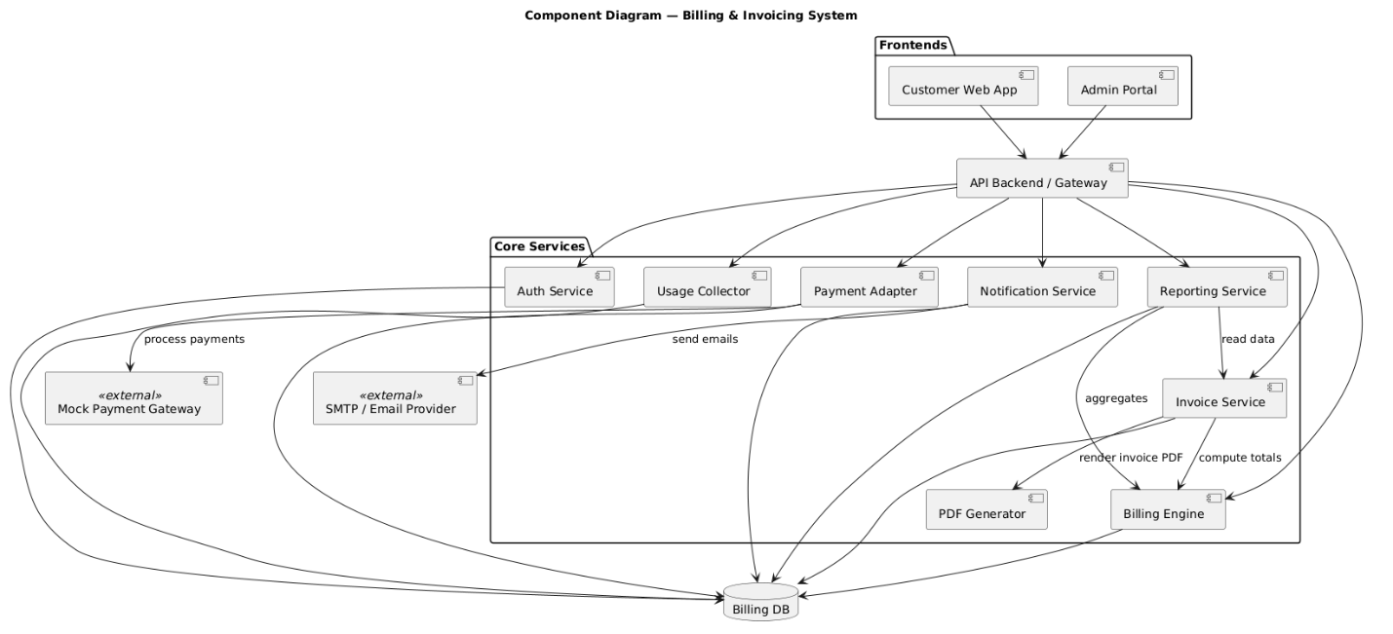

The Billing & Invoicing System component diagram demonstrates how modules and external systems communicate to enable various requirements of the system. The system is pulled through two main frontends: Customer Web App and Admin Portal, with both frontends communicating with the API Backend/Gateway. The backend is responsible for communicating with various core services which include: Auth Service for user authentication, Usage Collector for usage data intake, Payment Adapter for integration with the Mock Payment Gateway, Notification Service for sending alert and confirmations via email and, Reporting Service for obtaining data from the Billing Database to provide reporting capabilities.

All billing processes are done through specialized billing components, such as Billings Engine for calculating totals, rates, taxes and discounts, Invoice Service for generating invoices through reading and consolidating data, and PDF Generator for creating invoice documents in PDF format. A Billing Database retains all essential billing information, invoices and payment history which is made available to all services.

External systems are important too, as the Mock Payment Gateway processes all payments through the Payment Adapter, and the SMTP/Email Provider is in charge of all outbound communications. Finally, the diagram depicts the flow of actions: payment processing, email notification, data aggregation, and rendering of invoices. The various coordinated operations demonstrate how the

system will consistently provide secure, effective, and reliable billing and invoicing services.

## Class Diagram

Text + figures

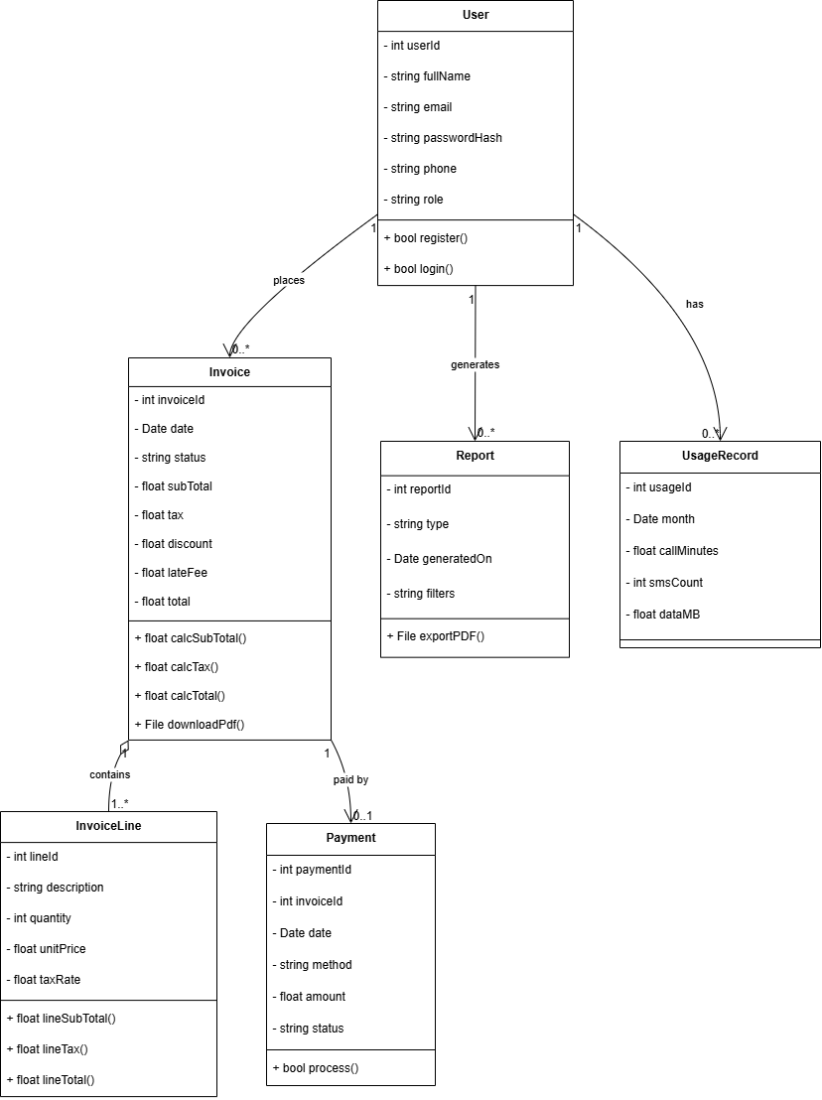

The class diagram for the Billing & Invoicing System describes the primary entities, attributes, methods, and relationships. The main class in the diagram is User, which allows persistence of user details including userId, fullName, email, passwordHash, phone, and role, and includes two methods: register() and login(). A User may create many Invoices, which contain invoiceId, date, status, subTotal, tax, discount, lateFee, and total. Invoice also includes methods for calculating subtotals, tax, total and methods for downloading the invoice as a pdf.

An Invoice contains one or more InvoiceLine, which describes the individual services or products that were billed for each InvoiceLine (lines) the specific attributes are: description, quantity, price, and tax rate; methods for calculating the line subtotals, taxes, and total. An Invoice may also represent a single Payment, which will include paymentId, payment method, amount, date and status, and a method for processing/updating the transaction.

also a User can create many Reports. These Reports also contain data related to billing or usage and could have attributes such as reportId, type, generatedOn, and filters, etc. A Report also has the capability to export it as a PDF. A User has UsageRecord. A UsageRecord contains monthly history of usage, such as minutes of calls, SMS count, and data usage (MB), etc. This structure allows the system to record and handle user data, billing data, and usage history, as well as reporting and payment processing in a structured way.

## Use case Diagrams (Per functionality)

Text + figures

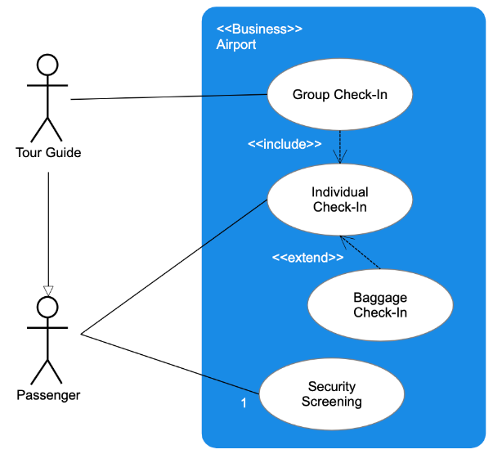

Figure A use case to ..........................

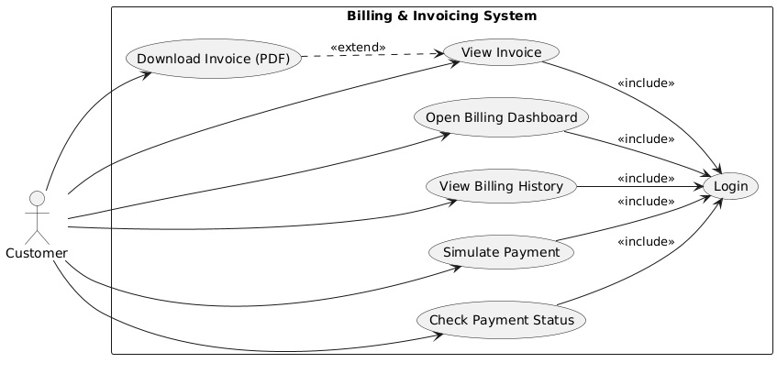

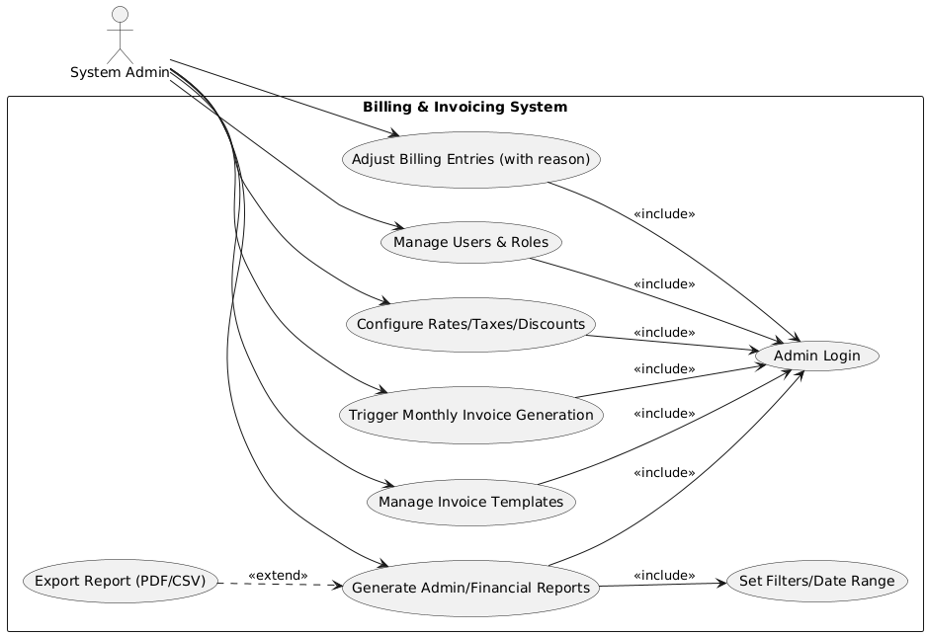

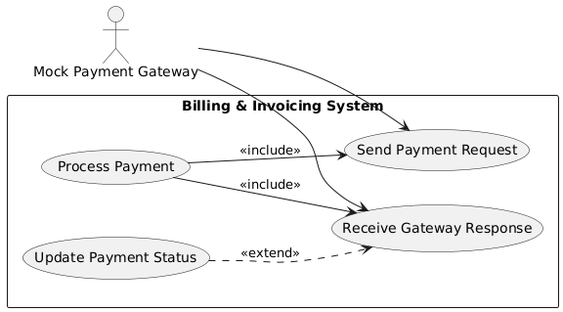

This Use Case Diagram presents how the Customer (the primary actor) will interact with the Billing & Invoicing System.

All paths begin with the Login use case because it is included in most other activities as the customer is required to log in prior to performing any other operation. After logging in, the customer can:

Access the Billing Dashboard which summarizes the customer account.

Access the Billing History which allows you check previous invoices and payments.

Access Simulate Payment which allows you to simulate or preview a payment process.

Access Payment Status which allows you to determine if a payment has been successfully processed and exists in history.

Access Invoice which allows you to closely inspect a bill before issuing payment.

The Download Invoice (PDF) use case extends the View Invoice use case, meaning, it can only occur after the invoice-specific use case is being performed. The 'include' to Login use case indicates that authentication is a valid prerequisite before each operation is attempted; furthermore, authentication provides the foundation of security for secure access to billing data and payment functionality. The use case diagram shows flow of interactions where each interaction depends upon secure login to access to all major interactions in the system.

## Activity Diagram

## Text + figures

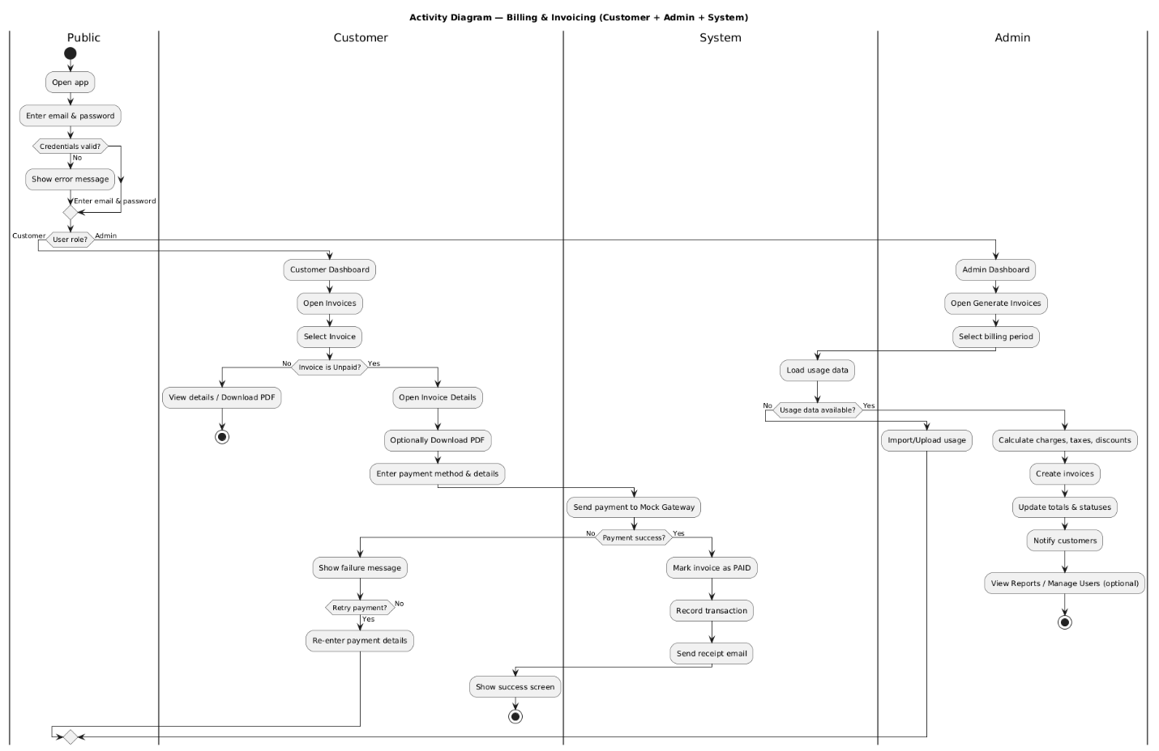

This Activity diagram represents the workflow for the Billing & Invoicing System. The diagram will display the actions of each individual role: Public, Customer, System, and Admin.

The flow begins in the Public area when the user opens the application and enters their email and password. At this point, the system checks the credentials the user provided. If they are not a match, an error message will be displayed and the user will need to try again. If the credentials are satisfactory, the system identifies the user role as either "Customer" or "Admin". If the user is deemed to be the Customer, the flow will move to the customer dashboard. If the user is the Admin, the flow would move to the admin dashboard view.

With the Customer path, the user is able to open an invoice from their dashboard and select one they would like to open. The system checks to see if the invoice is paid or unpaid. If it is already paid, they can view all details and download a PDF copy. If it is an unpaid invoice, they can open the invoice details, view and download a PDF copy if they wish, and go through the process of providing a payment method and details. The system then sends the payment to a mock gateway and checks to see if the payment is successful. If the user has insufficient funds or payment fails, the system draws attention to those findings and includes a message to pay attention to, the customer may continue on to check the status of the invoice, or retry to pay.

If the payment is successful, the system updates the invoice status as paid, generates a transaction that is recorded to the record of transactions, sends a receipt to the user's email, and displays a success screen.

For the Admin path, the admin creates invoices by selecting a billing period. The system first checks for usage data — if there is none, the process stops. If there is data present, the admin will import or upload usage information. The system then calculates the charges, taxes, and discounts, creates the invoices, updates totals and invoice statuses, and notifies any relevant customers. The admin can also run reports or manage users as optional tasks.

The diagram provides a clear definition of the sequential steps, decision points, and interactions between the customer, admin, and system overall to follow along with the associated billing and invoicing operations.

# Overall Design

## Design Overview

You need to present overviews on current design methodologies. In particular, describe the importance of UX/UI, UML, ERD and any other modelling languages and standards and de-facto standards in delivering better software design outcomes.

## Design Techniques Comparison

Compare the differences between the various design techniques.

Different design methodologies, such as UX/UI design, UML (Unified Modeling Language), ERD (Entity-Relationship Diagrams), and many other modelling standards differ from one another but all work hand in hand together to provide a complete design of the system, as well as an effective design.

UX/UI design is about the user’s experience and visual appeal. UX refers to the user's experience of the system, ensuring they can interact and navigate the system in an intuitive, efficient, and user-friendly way, while UI considers the visual appeal, layout and interactivity of the system. This design method is important in maximizing usability and ensuring overall user satisfaction.

UML is a way of visualizing system architecture and behavior using standardized diagrams, such as use case diagrams, activity diagrams, and class diagrams. This is useful for articulating system functionalities as well as the involvement of different actors/organisations to developers, stakeholders and designers.

Different design methodologies (UX/UI design, UML, ERD, and many other modelling standards) may differ from each other, but they all work together to ensure that a complete set of designs are developed, as well as a design that can be effectively designed.

UX/UI design relates to the users experience and the aesthetic of the design. UX identifies the user's experience of the system to ensure user interaction and navigation is intuitive, efficient, and user friendly within the system; while UI considers the aesthetics, layout and interactions. Each aspect of this drug method is important in being able to determine usability, as well as user satisfaction.

UML utilizes standardized diagrams (use case diagrams, activity diagrams, class diagrams) to visualize system architecture and behaviour. It provides overall a visual overview, as well as articulating system functionalities, involving various actors/organisations to developers, stakeholders and designers.

## Design Tools

Compare the differences between the various design tools. **YOU NEED** to hold your comparison using 4 different tools by comparing their advantages, disadvantages, and usage.

Table 1 Advantages and Disadvantages of types of each design tool

|  |  |  |  |
| --- | --- | --- | --- |
| **Tools name** | **usage** | **Advantage** | **disadvantage** |
| Tool 1 |  |  |  |
| Tool 2 |  |  |  |
| Tool 3 |  |  |  |
| Tool 4 |  |  |  |
|  |  |  |  |

Figma is a popular UI/UX design tool which helps teams create interactive prototypes and mockups. One benefit is that it is cloud-based, so the service can be accessed from anywhere and allows real-time collaboration. Many designers can edit the same project at the same time, which is great for collaborative support. One drawback is that while it is fairly powerful, many of its capabilities still rely heavily on an internet connection, which is not always available in some settings.

Lucidchart is primarily used to create UML diagrams, flowcharts and system models. It has a simple drag-and-drop functionality and allows for collaborative editing. The application comes with a lot of usable premade templates that provide layout to the designers to help speed the design process along. However, there are many limitations to the free version, and to obtain advanced capabilities will require a subscription, which can create a burden to many budget-conscious users.

Draw.io is an online diagramming tool that anyone can use for free when building ER diagrams, UML models, or other technical diagrams. Because it is a web-based tool that does not require installation and integrates easily with cloud storage services, such as Google Drive and OneDrive, Draw.io is easy to access. The completely free version is enticing, but this tool's interface is not as polished as paid tools and it doesn't provide some advanced design or collaboration capabilities.

Microsoft Visio is a professional diagramming tools used for UML, flowcharts, and process mapping. Visio is a very powerful tool with many templates and integrations, especially for Microsoft Office products. Because of this, Visio is a strong choice for enterprise situations. Visio is, however, quite expensive and it is also more difficult to learn for beginners than other tools making it less appropriate for hobbyist or low-budget projects.

## The preferable Design Tool and Technique

Identify and justify the design tools and techniques you have been selected for the designing of this application.

The design tools chosen for the realization of this project are Figma for UI/UX design elements, and Draw.io for system and database models.

Figma was chosen for UI/UX design elements because of its real-time collaboration capabilities, which allows for collaboration between the project design team and all project stakeholders. This helps facilitate communication and creates a seamless design experience. Figma supports real-time interactive prototypes, meaning it is easier to visualize the user interface, navigation flow, and the intended overall user experience before getting designing of the app.

Draw.io was chosen for UML diagrams (use case diagrams, activity diagram, and ER diagrams) because it is a free, cost effective to develop, web-based, and easy to use app that also has the capability of detail and accuracy when developing a system model. Draw.io integrates well with cloud storage platforms, making it easy to share or update a design either collaboratively or independently.

The value in using Figma for the interface design elements and Draw.io for system modeling elements is to ultimately help foster visual communication, perceived efficiency, and a structured development approach, for the design of the UI/UX and system modeling of the app.

## High-Level Design (HLD)

## Sitemap

Text + figures

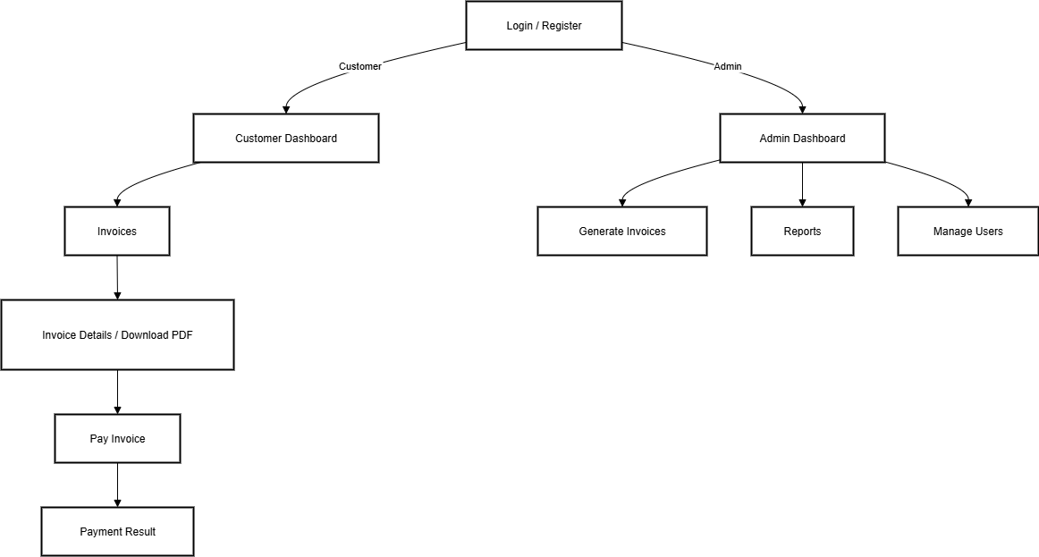

This map is a graphical portrayal of the user flow for the Billing & Invoicing System. It's a representation of both the users and the admins paths after they have gotten authenticated and signed in or registered.

It all starts with the Login/Register page, where users can be authenticated to go to either a Customer Dashboard after logging in, or create a Customer account if registering, and both Admin logins after logging in and sign up an Admin account at registering. The Customer Dashboard provides access to an customers Invoices, then the user has an option to view Invoice Details, then if they want to download the PDF if the invoice is unpaid they can go Pay Invoice, which leads to the Payment Result page that displays a success or unsuccessful payment.

The Admin, could log in to the Admin Dashboard, which allows the Admin three primary functions (Generate Invoices, View Reports and Manage Users). The prospect of these tools is to allow the Admin to conduct billing, view reports on the system and check if it’s operating properly, and manage accounts of other users.

Overall this sitemap presents a clear division of the user experience for customers and Admins, from customers perspective just as each invoice needs to have the intended flow of actions in a logical and efficient way, without problems or issues that would trip a user up.

## Wireframes

Text + figures

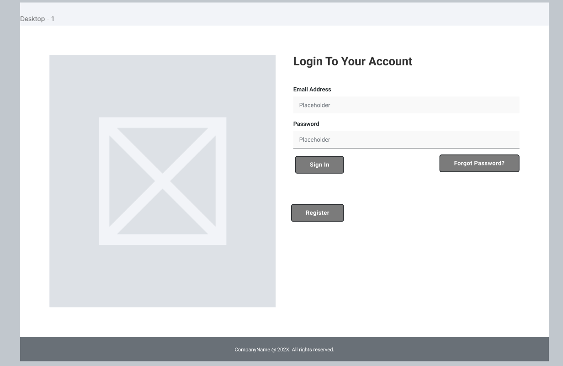

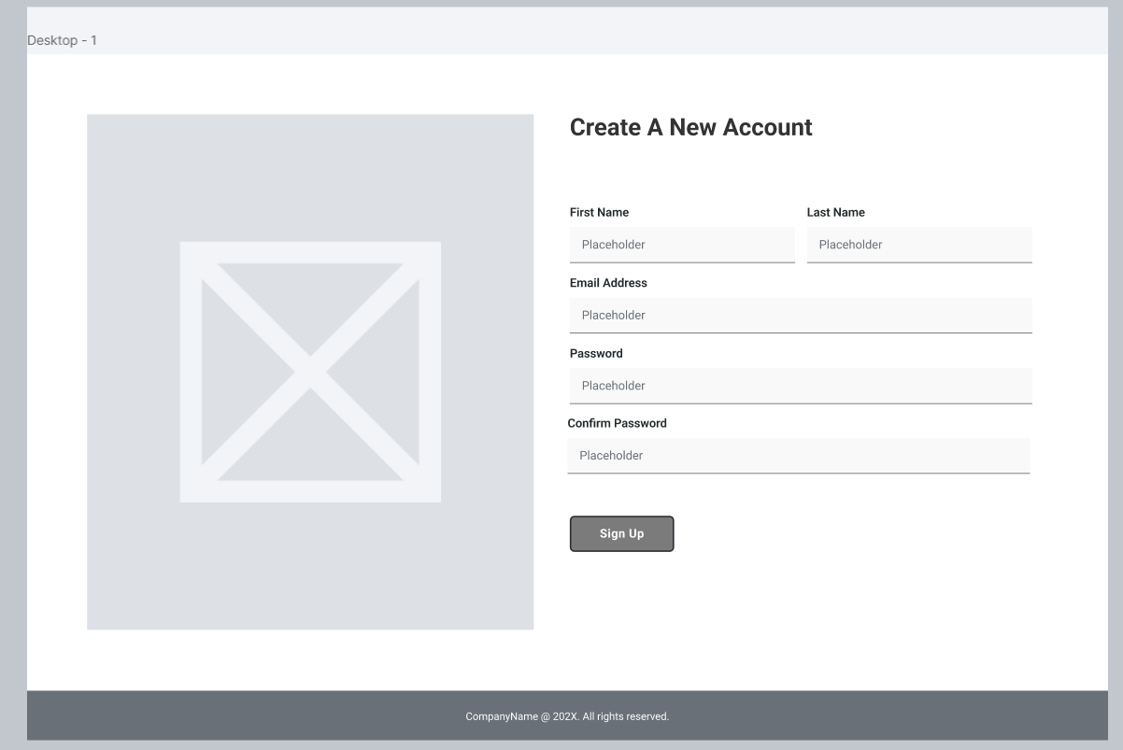

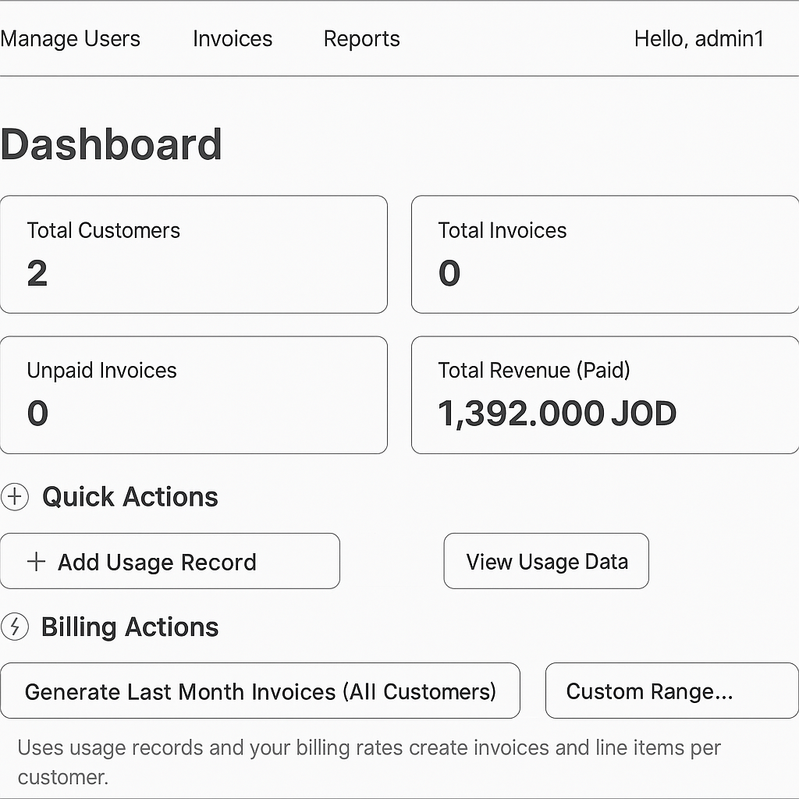

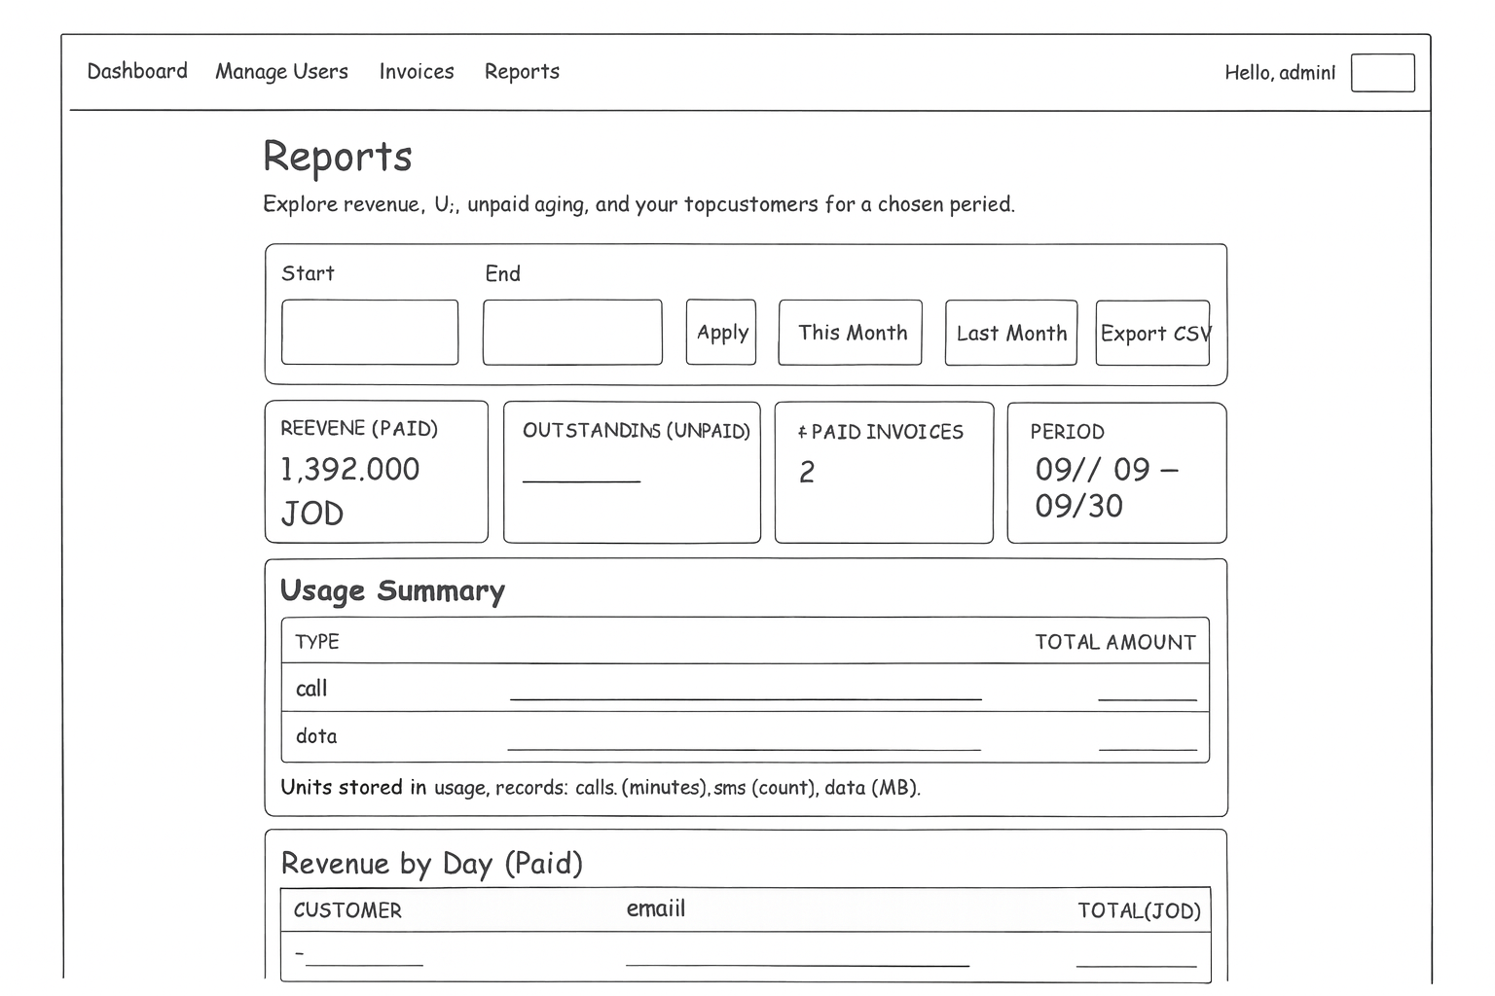

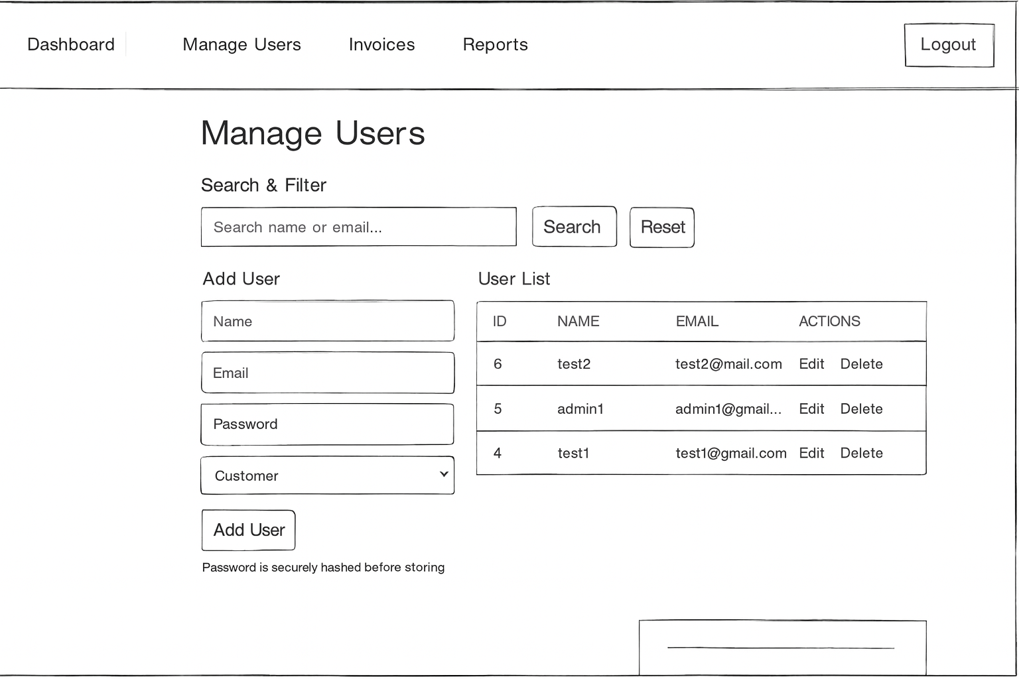

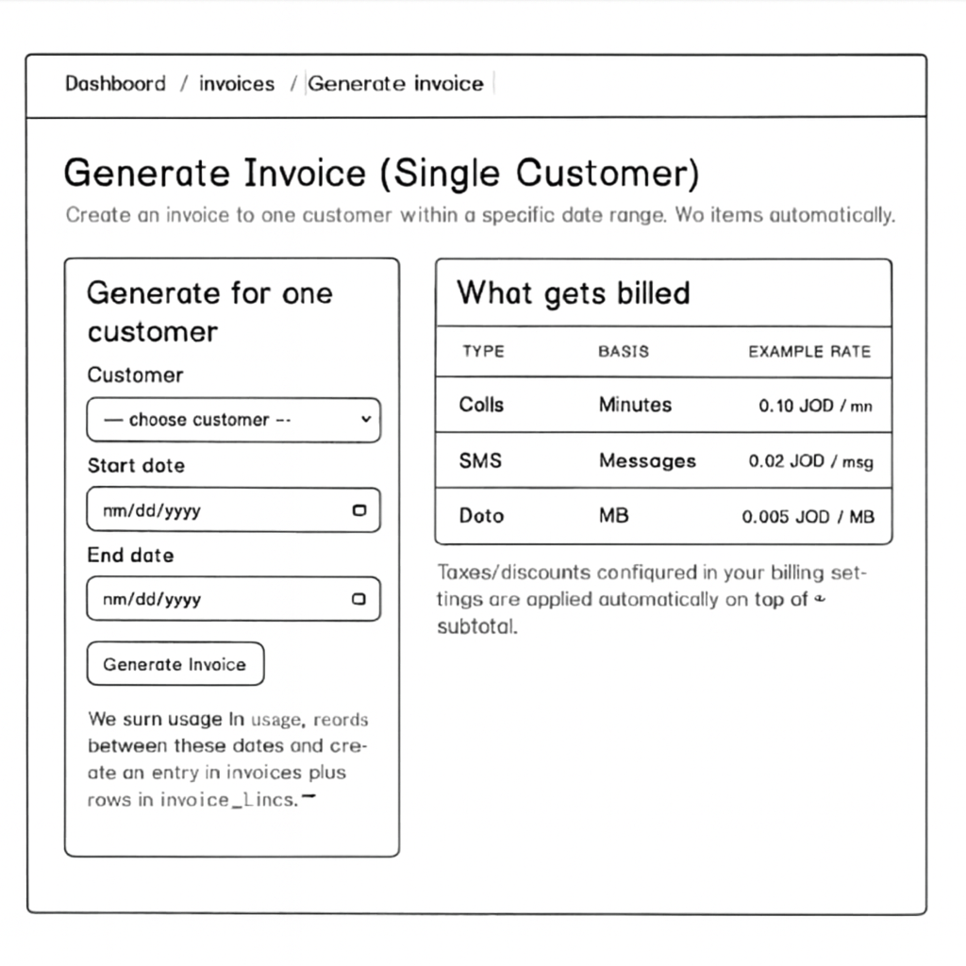

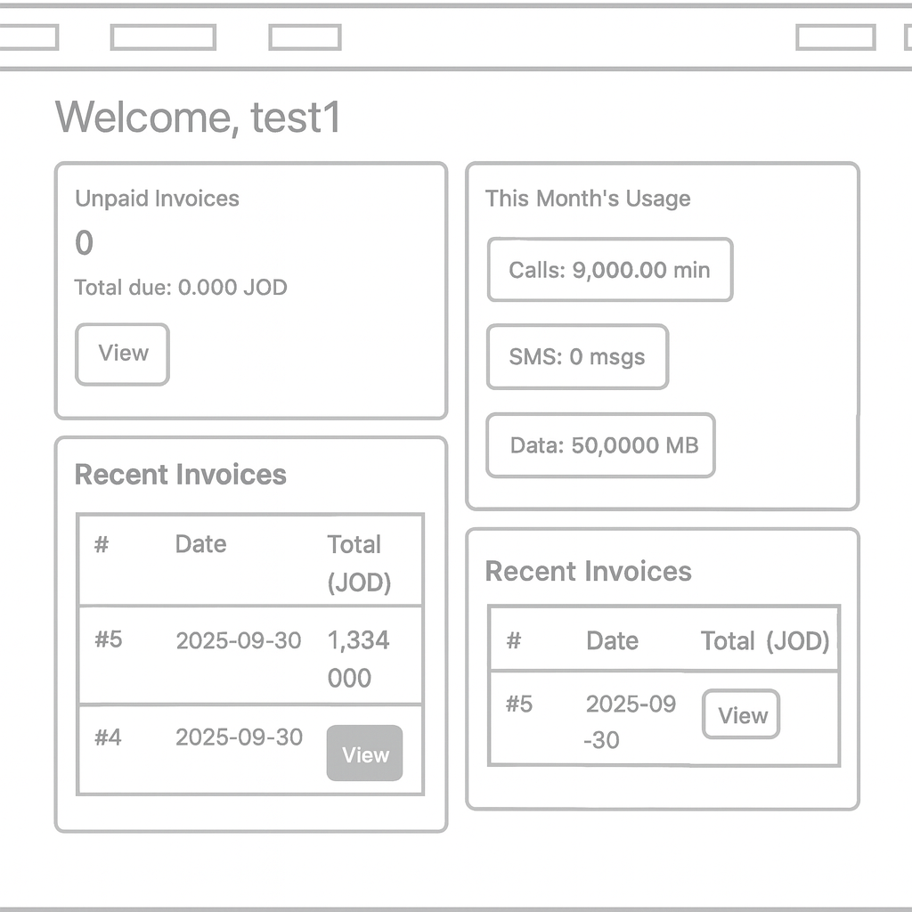

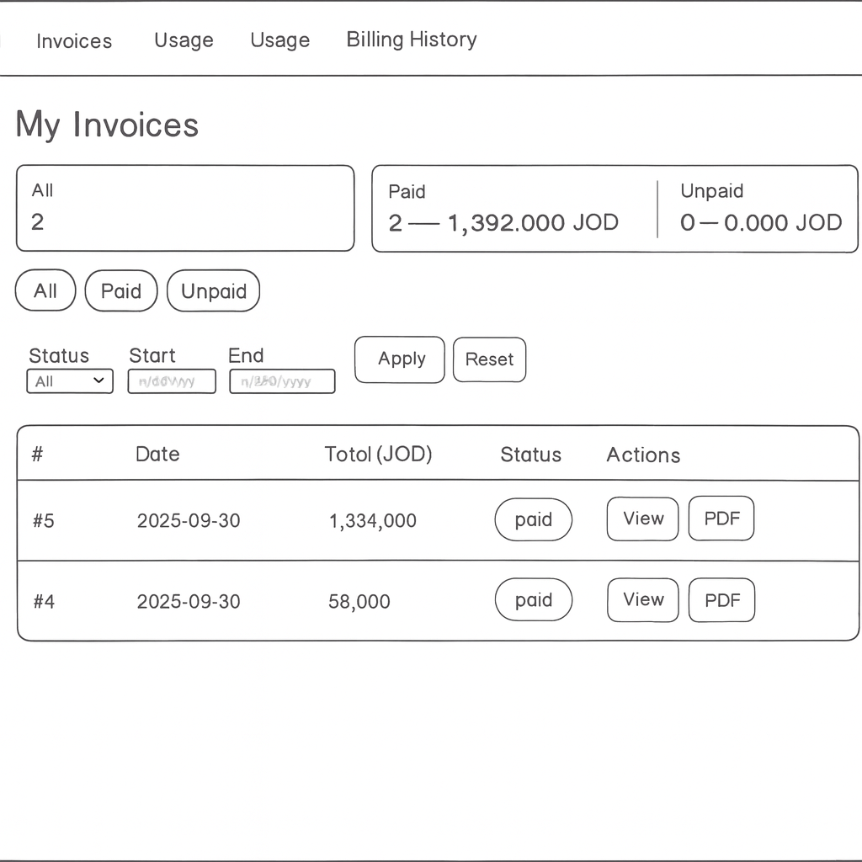

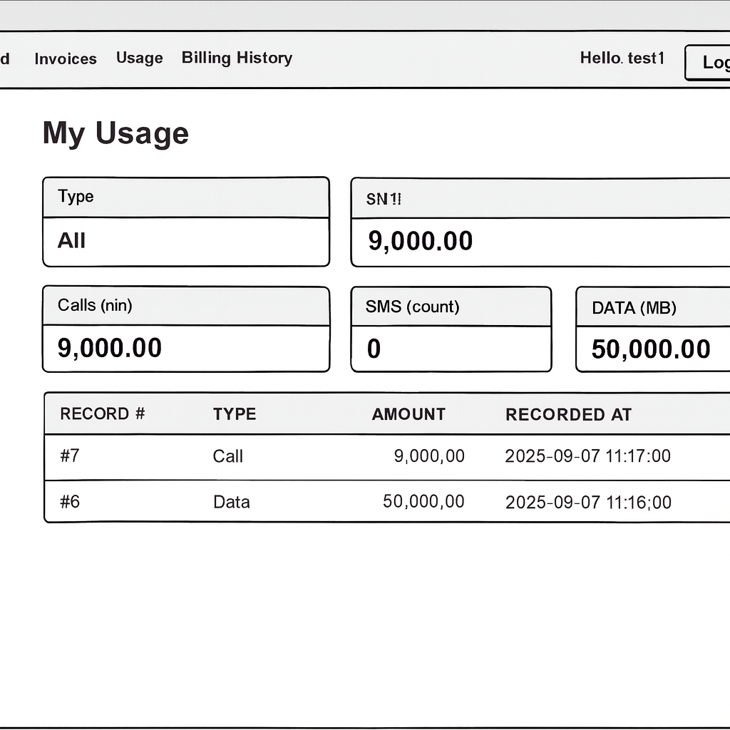

1. Log In Page

This is the screen where users can sign in using their email address and password to their account. Clicking on the "Forgot Password" link allows the user to recover their account and a button marked "Register" enables the user to create a new account with them. The left side has a large space for featuring, branding, a company logo, or promotional content.

2. Register Page

In this space, new users can provide their first name, last name, email address, password, and confirm password. Similar to the Log In page, the left side has a large space for images or branding.

3. Generate Invoice (Admin)

In this space, an admin can create a new invoice. On this screen, an admin can find a dropdown for the user, an invoice date, and input fields for service description, price, tax, and discount. It also offers a "Generate Invoice" button to finalize the process.

4. Reports Page (Admin)

This space allows an admin to generate and export reports as a PDF file. The interface includes dropdowns to select users, start and end dates, and what is being included in the report.

5. Admin Dashboard

The admin dashboard provides a summary view that shows the total users, unpaid invoices, and total income. Action buttons allow the admin to create invoices, view reports, and manage users.

6. User Dashboard

A user sees their details upon logon, the user details include their billing summary at which includes total owed, the last payment, and a summary of their usage (data, call minutes & SMS usage). Action buttons allow the user to in-view their latest invoice, make a payment, and download a PDF of their billing statement.

7. User Invoices List

The display of relevant invoices that are associated with the user, displayed in a tabular format. The columns shown are invoice number, date, amount, status column (paid/unpaid), and action buttons (e.g. "Pay Now" or "View"). The user quickly manages payments owed.

8. Manage Users (Admin)

This is a display of all available users of the system which provide some details of their author name, role, email, and profile attributes. This view will include pagination for viewing multiple pages of users and an "Action" column to do management application usage.

## Mockups

Text + figures



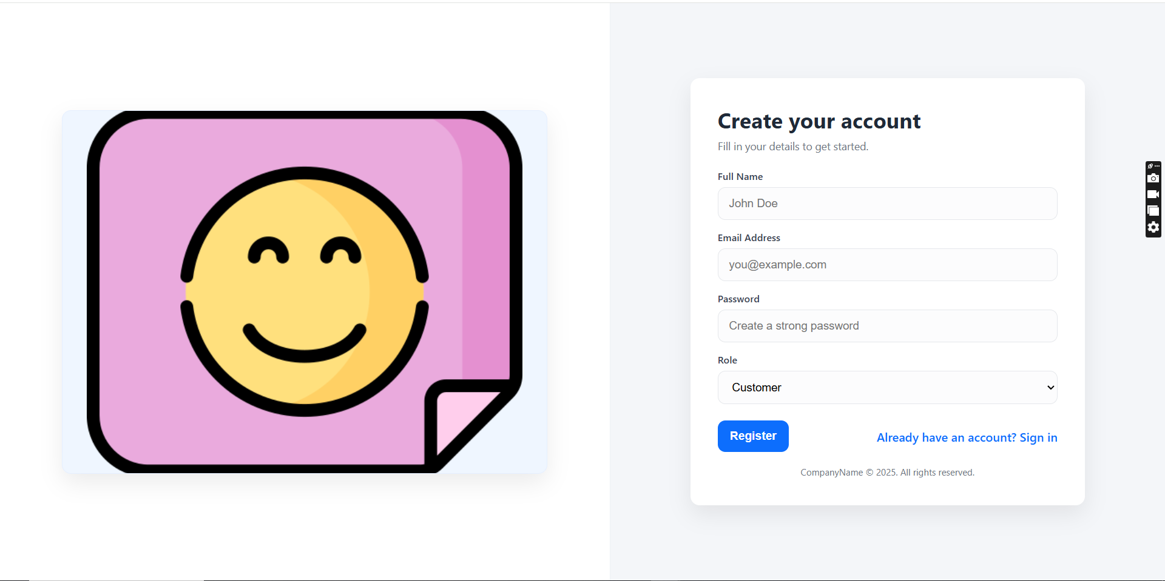

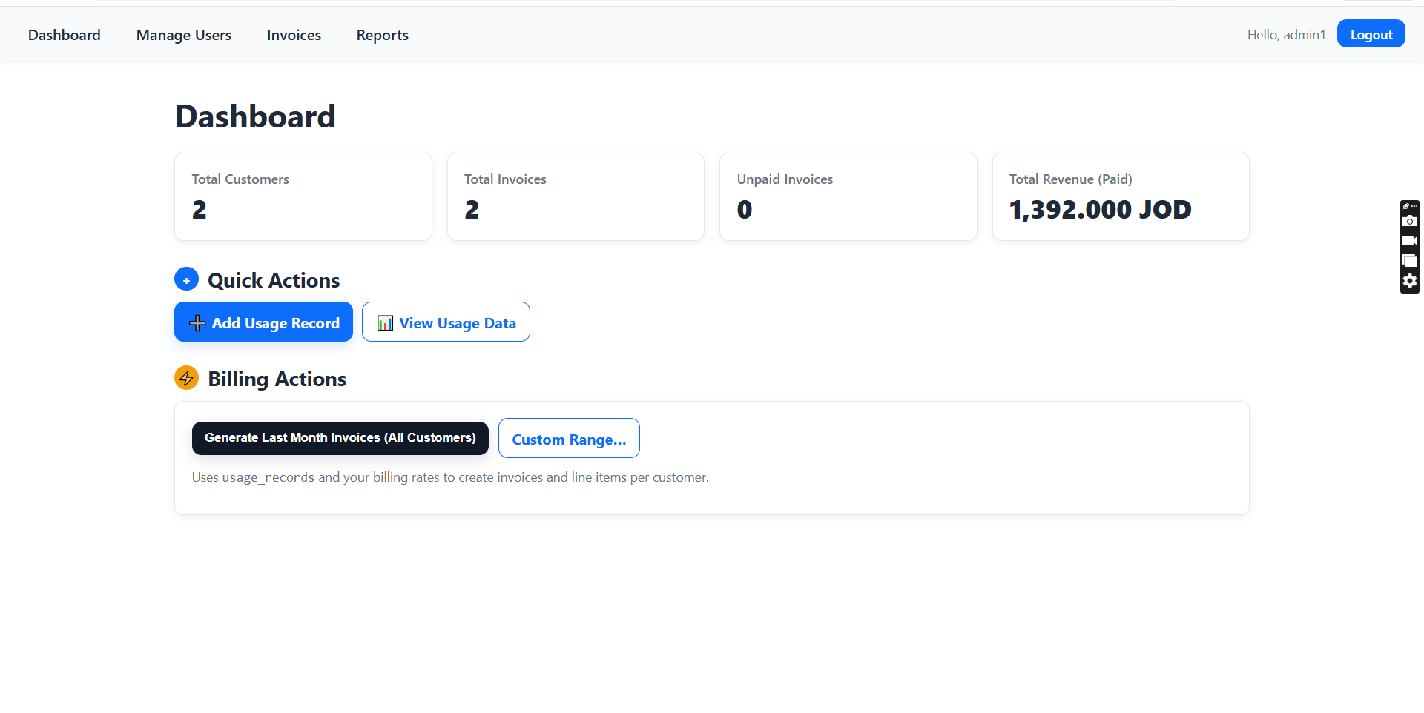

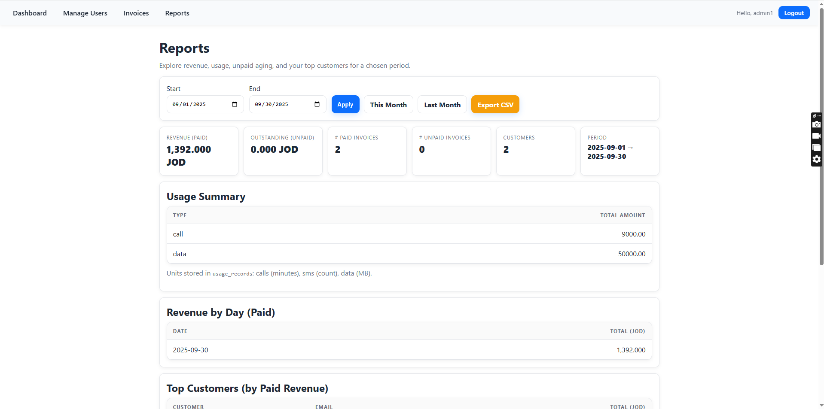

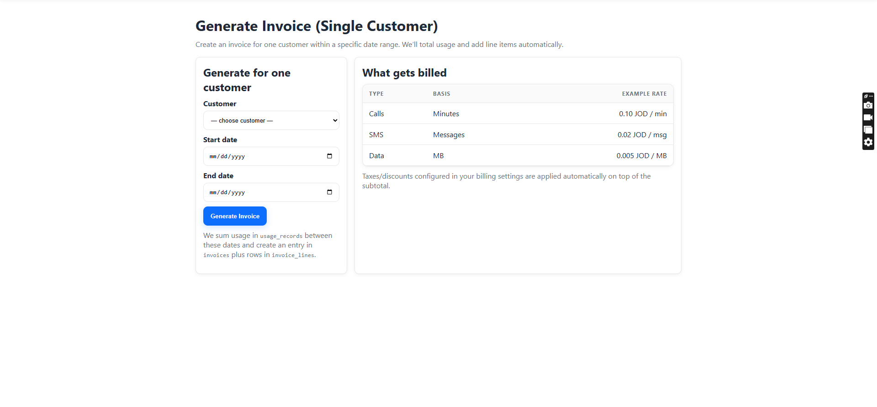

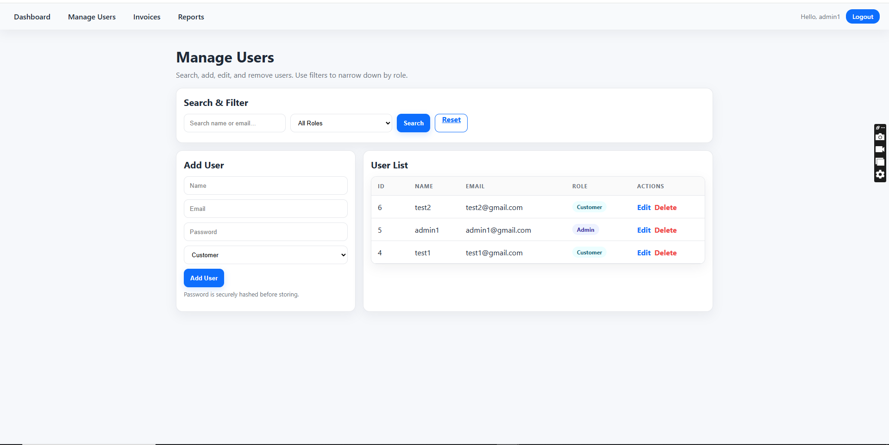

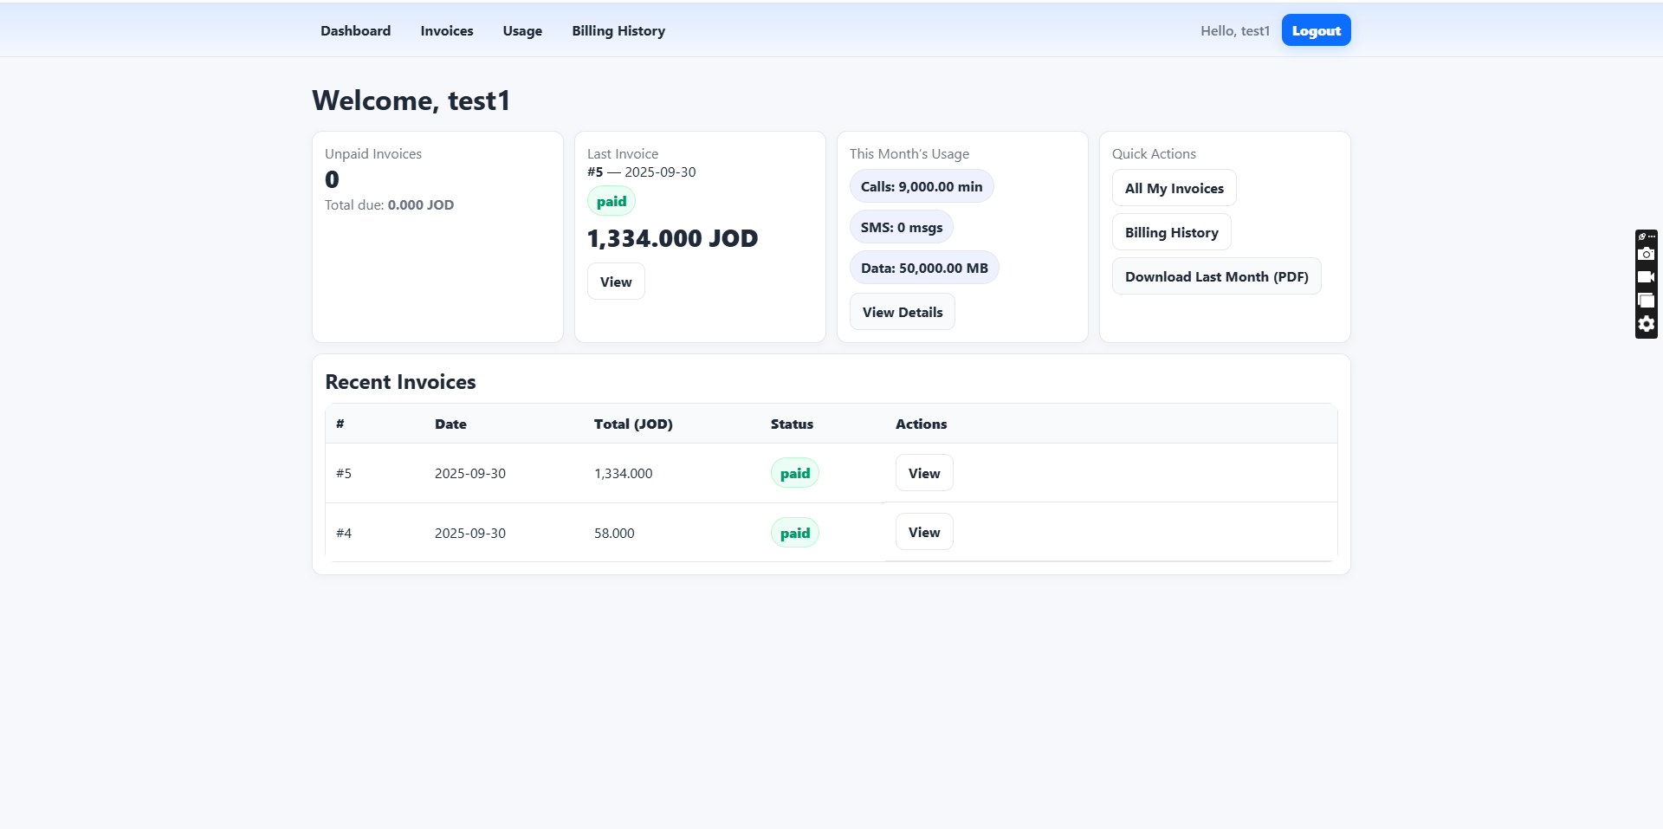

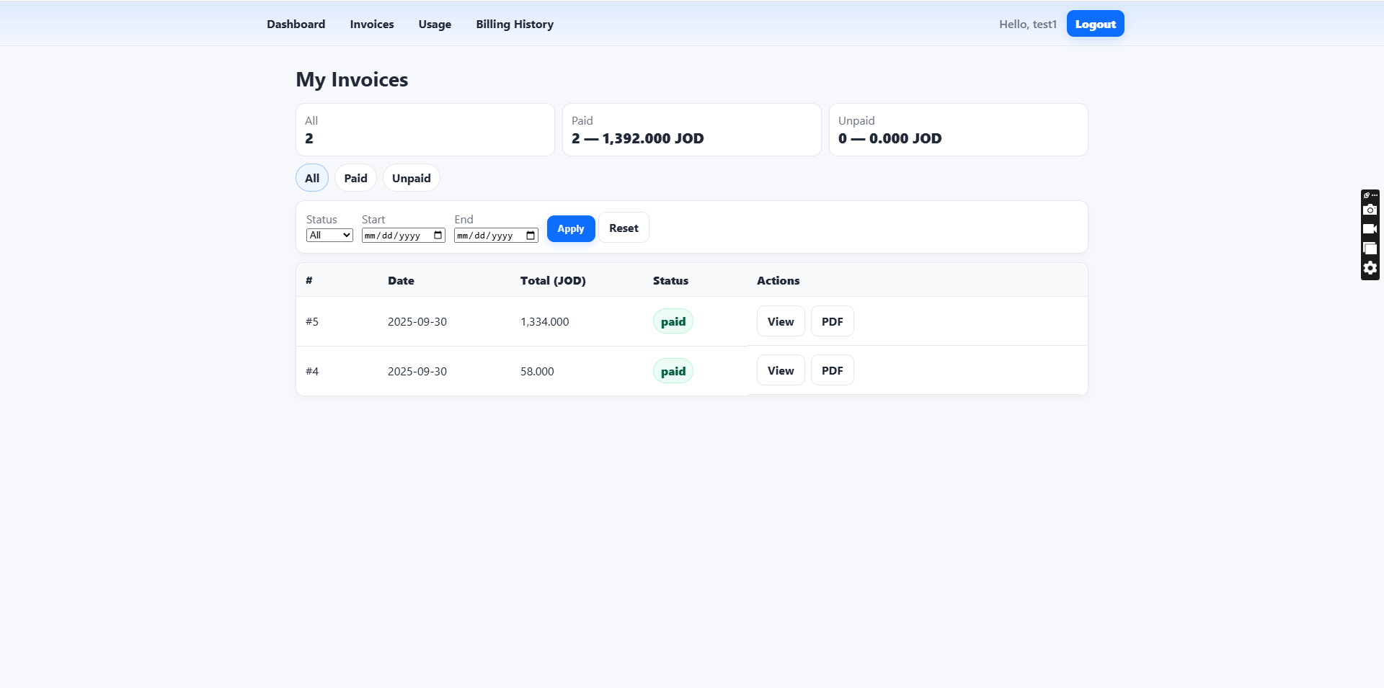

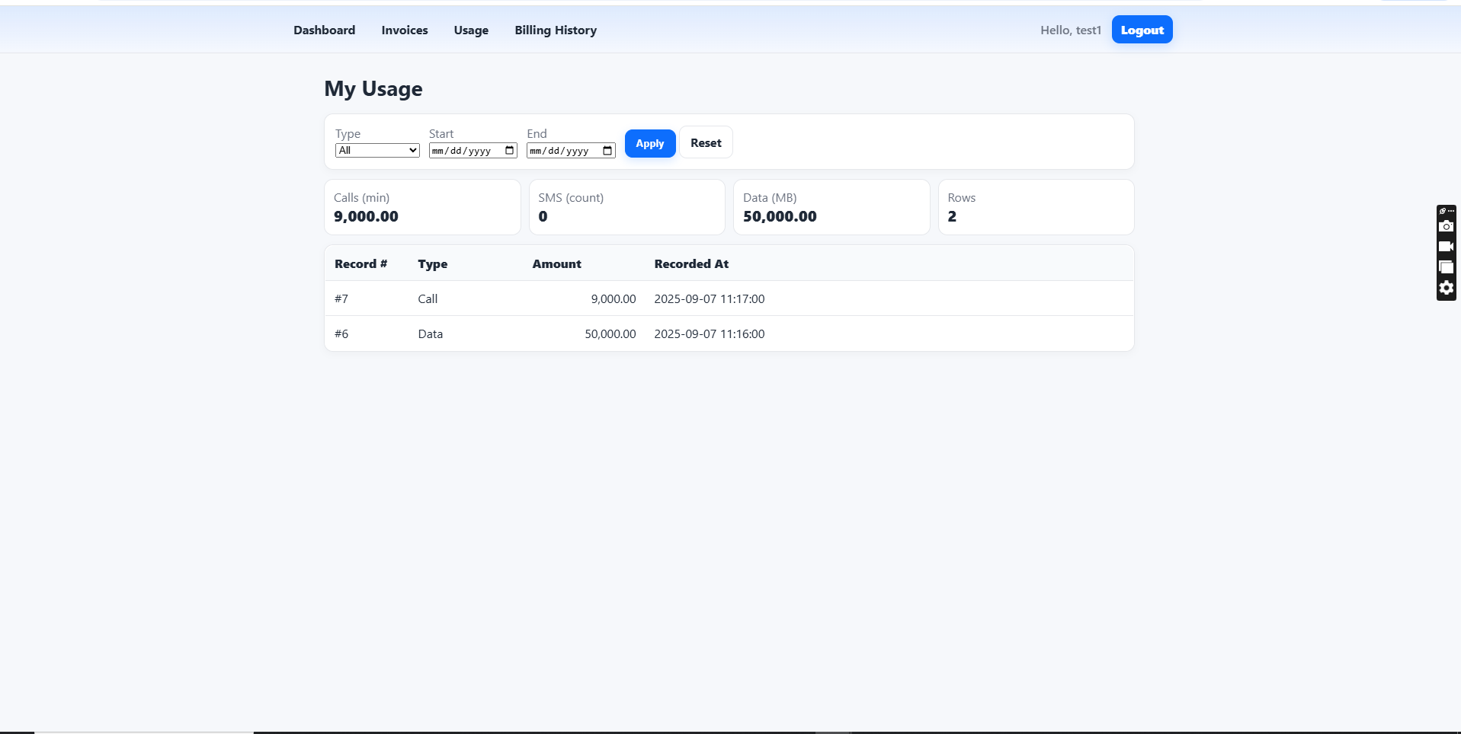

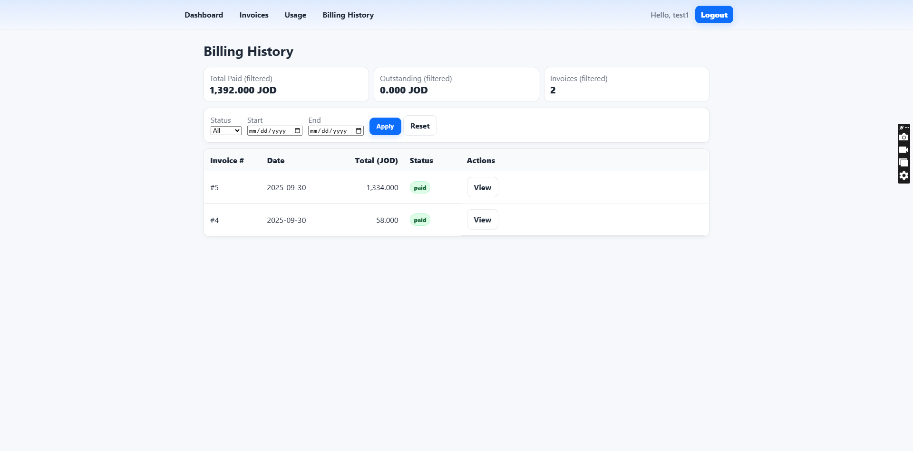

1. Login Page

This screen provides the user the ability to log in to their account with their email address and password. There are buttons for Sign In, Forgot Password?, and Register. To the left is a graphic about online payment, giving the page a visual look and relevant theme.

2. Registration Page

This page provides the user with the ability to create an account by entering their first name, last name, email, password, and confirming their password. The design is the same as the login page, with the form on the right and a graphic on the left.

3. Generate Invoice Page (Admin)

This admin page allows the administrator to create invoices by selecting a user from a drop-down list, entering a service, price, tax, invoice date, and discount. The action is finalized with a Generate Invoice button.

4. Reports Page (Admin)

The Admin page allows to generate reports, by selecting a user, date range, user status, and additional filters from drop-down lists. The Export to PDF button enables downloading the report directly.

5. Admin Dashboard

This page gives a broad view of the system activity including the total number of users, outstanding invoices, and total revenue generated. Quick-action buttons for Generate Invoice, View Reports, and Manage Users are easily visible.

6. User Dashboard (Billing Overview)

Once the user logs in, they will see the total amount that is due, last payment information, and usage summary (data, calls, SMS usage). The user can also view their latest invoice, make a payment or download a PDF with buttons to complete those tasks.

7. Invoice List (User)

This table lists the invoice's for the user, with fields including invoice number, date, amount, and even status (paid/unpaid). The action buttons listed are View or Pay Now.

8. Manage Users Page (Admin)

An admin page showing a list of users in a table with columns. The users can be displayed by role, email, titles, and action buttons. The page is paginated to allow paging through many users.

## Low Level Design (LLD)

## ERD

Text + figure

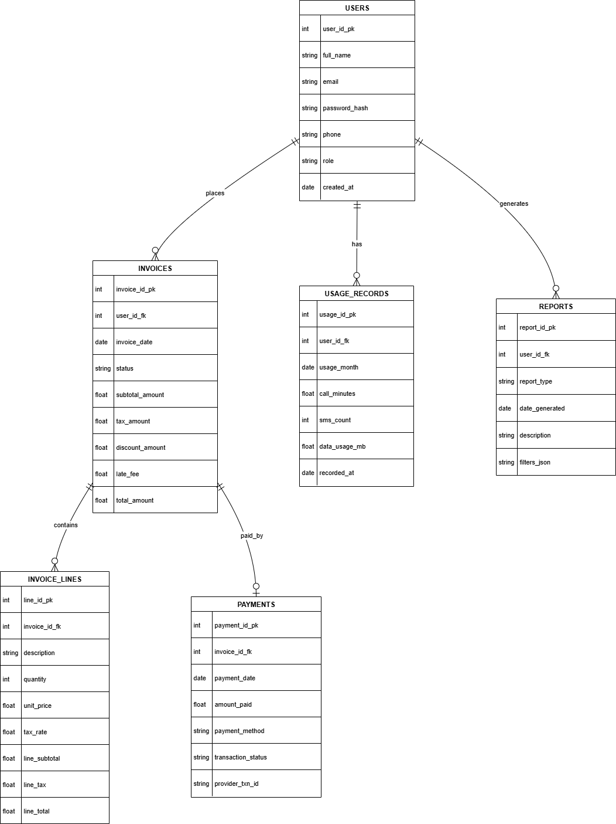

This Entity-Relationship Diagram (ERD) shows the database structure for the Billing & Invoicing System and how the different entities interact to store and retrieve data.

The USERS table stores user data including user_id_pk, full name, email address, password hash, phone number, role (e.g. admin or customer) and created_at timestamp. Each user can have one or more associated invoices, usage entries or reports created.

The INVOICES table stores invoice details, such as invoice date, invoice status (paid or unpaid), subtotal amount, tax, discounts, late fees, and total amount. Each invoice also wishes to have a user_id_fk field to associate with the user. Invoices can also link to multiple invoice lines and be associated with payment records.

The INVOICE_LINES table stores each line/customer service element/line item of an invoice, including the description, quantity, unit price, tax rate, and subtotal. The table supports being able to bill precise items for a single invoice for multiple products or services.

The PAYMENTS table contains payment transaction details, including payment method, amount paid, transaction status, and provider transaction ID. Payments are connected to invoices based on the invoice_id_fk key, so it is easy to track financial transactions.

The USAGE_RECORDS table indicates how the customer used the service - for example, call minutes, number of SMS sent and data usage in megabytes for a month. This may or may not be used to generate invoices on services consumed.

The REPORTS table will allow users (applies to admin) to create a number of reports. The report type, date of generation, description, and filters used to generate the report are recorded as JSON format. These reports can be used for analytic and monitoring purposes.

This relational structure planted a seed to preserve data integrity, utilize efficient queries, keep all billing, payments, usage records relationship strong, and eventually, to scale the system to accommodate features for a possible future system.

# Overall Development

## Development Overview

You need to present overviews on current development methodologies. In particular, research the use of software development techniques (1) RAD platforms (code generation platforms, low-Code, no code), or (2) building your application from scratch by fully writing code, or (3) Customization of a current product

## Development Techniques Comparison

Compare the differences between the various development techniques.

An option often used is **Rapid Application Development (RAD),** which prioritizes speed and user engagement. With low-code or no-code platforms, the developer can implement an application very quickly with drag-and-drop features and pre-built components. Therefore, RAD can efficiently engage in prototyping, i.e., generally with user feedback and it very quickly reduces the total cost. The downside is that they often limit the flexibility and scalability of applications, especially when system functionality requires customizations or substantial integrations.

Another option is to build the system entirely using **traditional coding**. The advantage is that it allows for control over the application's architecture, feature set, and performance. Developers can customize each part of the system exactly for the project requirements and in the long run will produce a more scalable and customizable application. The disadvantages are higher cost, a lengthy implementation process, and the requirement for a high level of technical capability to build and maintain the system.

A third method is customizing a current product (also known as tailoring a commercial off-the-shelf **(COTS)** system). This is a method that allows the organization to adopt an already developed software package and tailor it to their needs. The positive aspects for the organization are that it takes less time to deploy (it is faster) and it may cost less money upfront (the base system is available). The drawback is that customizing the system is usually limited to what the vendor allows. There is also potential to conflict with future upgrade capabilities. For all of these reasons a fully customized system eventually becomes less flexible, and the relationship with the vendor becomes stronger and more influential.

To summarize, the RAD methodology works well in instances where the speed of development and prototyping are a priority; the custom development methodology is ideal for very complex and highly tailored systems; and the customizing methodology works for products that are “close” enough to the current capability but need some customization for needed adjustments to accommodate unique requirements.

## Development Tools

Compare the differences between the various development tools. **YOU NEED** to hold your comparison using 4 different tools by comparing their advantages, disadvantages, and usage.

Table Advantages and Disadvantages of types of each development tool

|  |  |  |  |
| --- | --- | --- | --- |
| **Tools name** | **usage** | **advantage** | **disadvantage** |
| **Bubble** (No-code) | To build full-stack web applications without writing code for start-ups and prototypes. | Very fast to create applications, visual drag-and-drop capabilities, database and workflows included. | Limited customization options, problem solving, performance issues when apps scale in high volume. |
| **Wix** (No-code) | Website for small business, portfolio and e-commerce sites. | Extremely easy to use, lots of templates, hosting included. | Less control when customizing backend logic, scalability when building larger apps. |
| **Zoho Creator** (Low-code) | Enterprise-level business applications (HR, finance, project management). | Good combination of drag-and-drop and custom coding, offers Zoho integration. | Advanced features require more technical knowledge, subscription pricing. |
| **Cloud Wizard** (Code generation tool) | Automatically generates boilerplate and code templates for developers. | Reduces time and effort for developing apps by speeding up development and repetitive coding. | The generated code may need a lot of customization, if used routinely could result in messy code. |

## The preferable Development Tool and Technique

Identify and justify the development tools and techniques you have been selected for the development of this application.

For the implementation of our billing and invoice management system, we chose HTML, CSS, and JavaScript for the front end, and PHP for the back end. This solution was a balance between simplicity, dependability, and good compatibility across hosting environments. PHP works seamlessly with relational databases, so it provided a viable way to implement dynamic server-side features such as user authentication, form submission, and invoice generation.

We used a modular style of development to define the system, so, each feature (e.g., user account management, generating invoices, viewing reports) was designed and implemented as an independent unit. This provided cleaner and more maintainable code, and a system that was clear, describing each feature independently and comprehensively. It also permitted easy extensibility.

Using plain JavaScript also enabled us to build a responsive and interactive front end for our system, while small and lightweight, without needing to sort through Edge cases, like import or module issues in large front end frameworks, and modules, and having to ship a significant amount of boilerplate code with our application, as well as keep the code simple and straightforward.

## Software Development Methodology

You need to Justify your selection for the software development methodology by listing the advantages and disadvantages of your preferred methodology.

The methodology chosen for the creation of the billing and invoicing system is Agile. Agile was selected as it allows the project to be realized in small iterative sprints, where each sprint can focus on delivering a functional feature such as the invoice generation, payment integration, or reporting. This is a perfect fit for our project, as each of the functional requirements can be realized, tested and adapted in cycles instead of one bulk delivery at the end of the project.

The benefits of Agile are flexibility to introduce changes in the work product, it allows for constant feedback from stakeholders, reduces risks by delivering productive features incrementally. And this means if billing rules change, for example stating new taxes or discounts are assigned, if the users wanted to improve on the system after testing and deployment, all can be done in a timely manner. Agile also enhances collaboration between the development team and users and therefore increases the chance the final system will meet real needs.

Agile also has its disadvantages. Agile activities require an active involvement of stakeholders throughout the process, and this could be problematic if the stakeholders are not consistently checking their feedback. Agile relies on robust project management to maintain the sprint schedule and manage issues such as scope creep. Also, documentation, while working towards working software rather than upfront detail, is sometimes less detailed than project methodologies like Waterfall.

Despite these disadvantages, Agile is still the most applicable methodologies for this particular project complex. Agile's use of iterations, adaptability to changing requirements and processes, and iterative development environment with executable working features can provide the project flexibility and reliability, in order to successfully develop a high security, efficient, user-friendly, and maintainable billing and invoicing system.

## Overall Design and Development Justification

You need to justify your solution to a business-related problem and your preferred software design and development methodology, by comparing between the various software development tools and techniques researched.

The identified business problem is inefficient and error-prone manual billing and invoicing. Organizations who utilize manual methods will regularly incur delays, miscalculations, and difficulties in securely tracking payements. As a response, the project proposes developing a custom-built Billing and Invoicing System, using ASP.NET, which will lend enough control to manage system functionality, data security, and scalability.

Our chosen software development methodology is Agile, mainly since it will allow for the complete, iterative, and incremental development of the system. Individual features such as generating invoices, processing payments, and reporting will be delivered to the user in short, but highly functional increments. One of the of primary benefits of using Agile is its propensity to encourage change as requirements are better clarified, flexible levels of engagement with collaboratively-minded stakeholders on a consistent basis throughout the project, and of course ultimately, useful software in the hands of real clients as early as possible through regular updates of working software which, at best, reduces risks for both developers and clients while improving the overall satisfaction of users. The downside to Agile is that it requires the continuous involvement in the development process by stakeholders, and requires adequate project scope management to avoid issues such as scope creep.

Agile offers a great deal of freedom compared to Waterfall. Waterfall is linear and restrictive in its approach and works best with stable requirements with limited chances that they will change. You wouldn't want to use Waterfall for a system like billing and invoicing, because it may evolve based on business needs. Similarly, while it is true RAD emphasizes prototyping features quickly with low-code/no-code tools, you might be limited in terms of customization. For example, you might if you are implementing a secure financial system with complex billing rules. Finally, DevOps leverages continuous deployment and monitoring of features, but it adds another layer of complexity that would not likely be included in the academic context of this project.

For these reasons, Agile with full-code development in ASP.NET is the best combination of responsiveness, reliability, and control. We can solve the business problem in an adaptive manner that produces a secure and maintainable solution that is easy for the users to interact with!

## Development Plan Presentation

## Peer review feedback

Document any feedback given to you during your formal presentation.

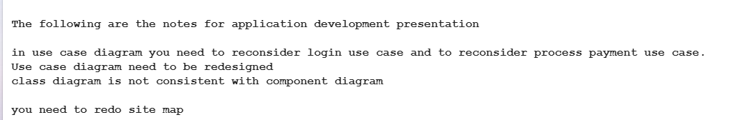

## Interpret the peer review feedback

Modify your Software Design Document to interpret your peer review feedback and reflect any new insights or considerations.

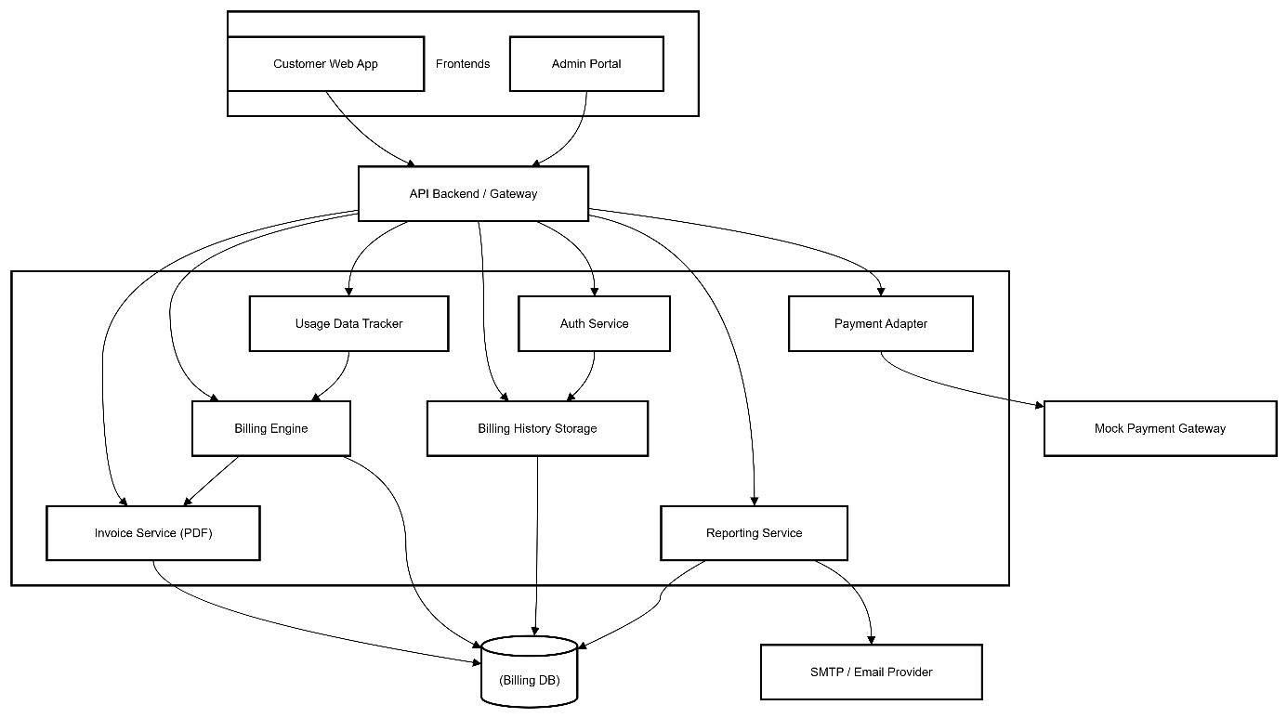

Modified Component diagram

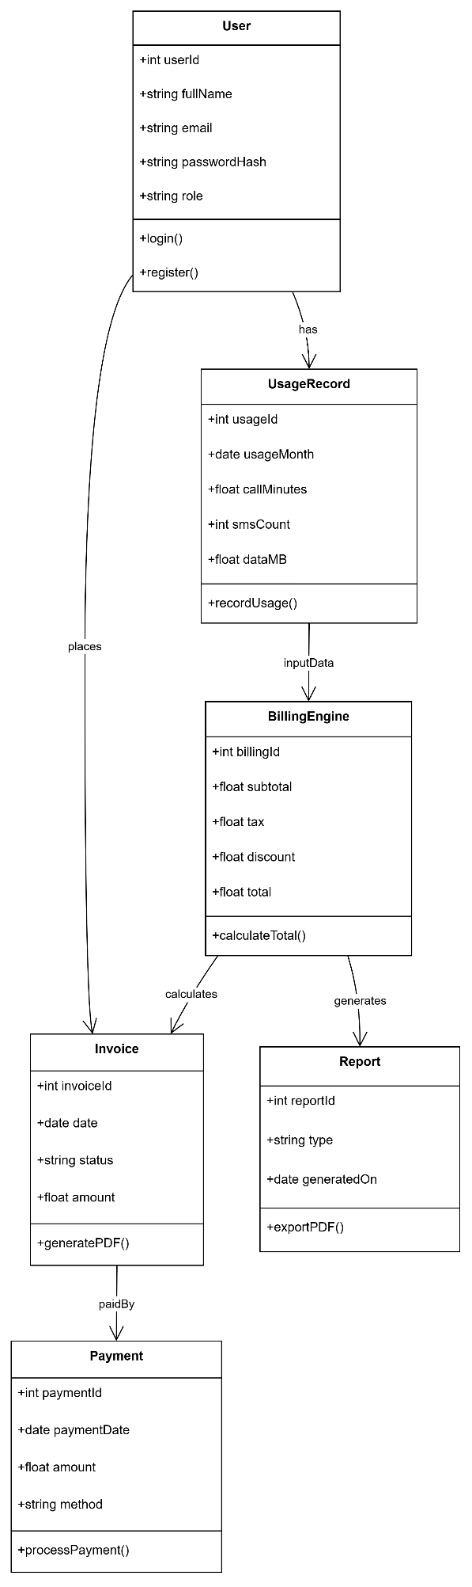

Modfied Class diagram

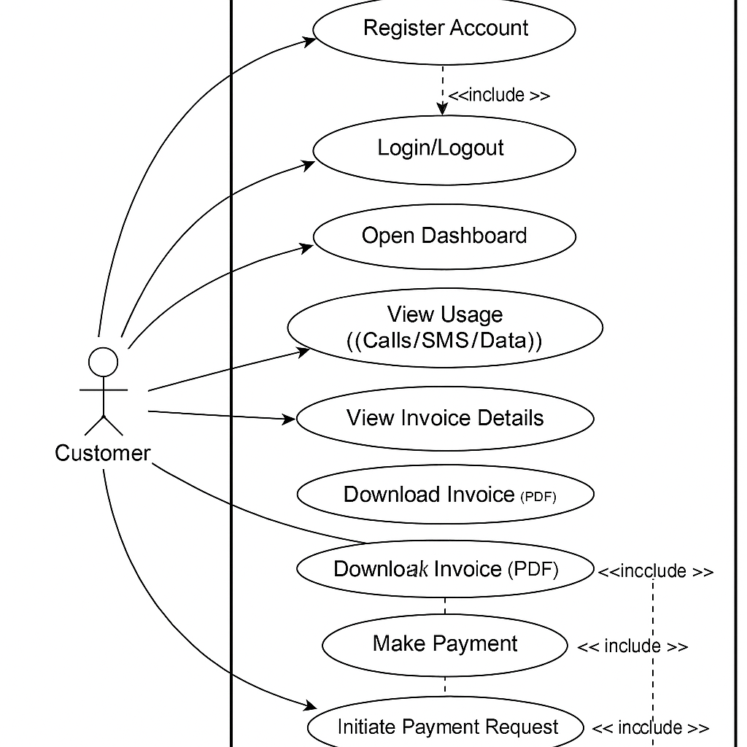

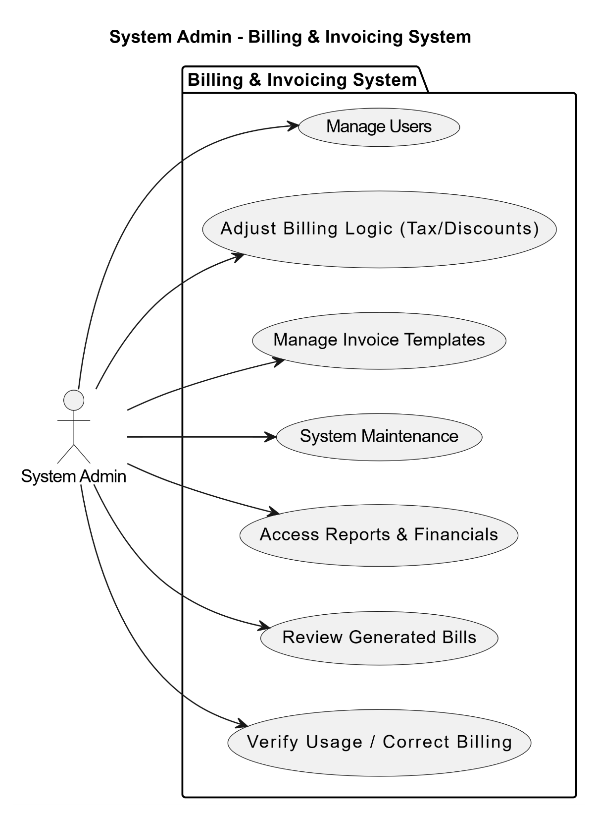

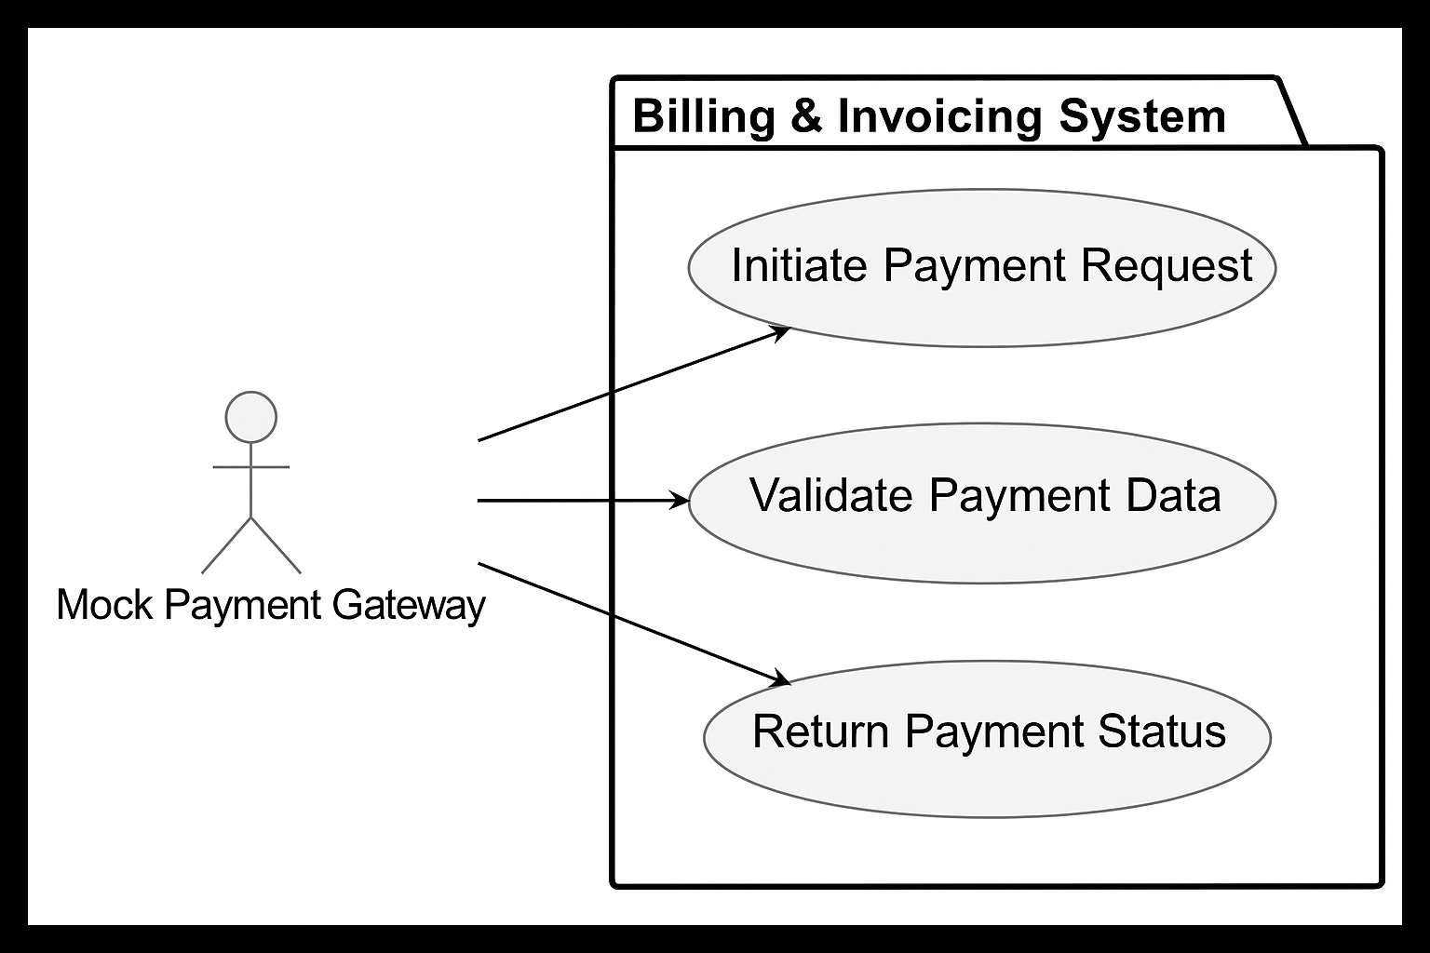

Modified use case diagrams

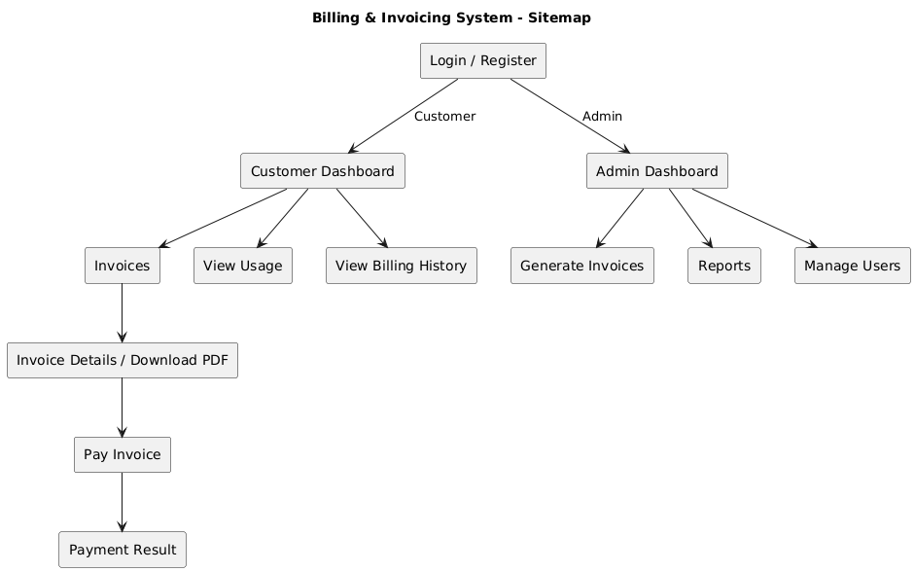

Mopdified Sitemap

## Identify and evaluate new opportunities

Identify any kind or type of opportunities not previously considered in the feedback you got. Also, you need to evaluate any new insights, ideas or potential improvements to your system and justify the reasons why our have chosen to include (or not to include) them as part of this business application.

Once we had the core functionality of our billing system implemented, we recognized several new opportunities that weren't part of development and project process. Any refined improvement we identified were:

Role specific dashboards for customers and admins. This would improve clarity by surfacing the relevant information for that role (user's usage and billing stats for user & system metrics or revenue summary for admin)

We saw additional value in adding alerts for customers when high usage thresholds are approached. As of now, there is absolutely no visibility until billed. Purposely sending them an email in real-time or using in-app notifications to let them know they were approaching limits would help with transparency, better user experience, decrease billing disputes (that could impact revenue), and we are already collecting that backed and not using the service ability we have via SMTP for notification.

We see a distinct advantage to refactor billing logic to a single, maintainable class (BillingEngine) on the backend side, which would make it much more maintainable as well as facilitate future features like dynamic pricing tiers or coupon codes.

In addition, we would like to implement some basic kind of auditing log for sensitive actions (e.g., invoice edit, role change) to hold ourselves accountable, which is especially imperative in any space dealing with financial data. We did not choose to implement some improvements (like moving to a modern PHP framework like Laravel, or to add multi-language support), because this would create unnecessary complexity, as well as lack of tangible business opportunity. Instead, we focused on low-hanging fruit that is immediately applicable, and keeps us aligned with our current capacity but leaves options open for future scalability.

## Application Development

## Database

Why we use it, your database type (Oracle, MySQL, SQL, IBM, PostgreSQL, H2), and your database structure.

We have chosen to use a MySQL relational database to persist and manage all system data because of its reliability, its open-source thoroughness, and because of its extensive support and use for web applications. MySQL is commonly used with applications that rely on PHP, allowing it to integrate seamlessly with our backend, which was also a deciding factor.

The logical structure of the database is organized into tables with the following core tables. users, invoices, usage_records, payments, along with other normalized tables so as to remove unneeded redundancy. For example, the users table for authentication and role linking, and the usage_records table for SMS, call records, and data per user. The schema expected from our database design ensures referential integrity, through logical referential relations using foreign keys during linking for users and their invoices, and for users and their payments.

Our schema structure also has the unique capacity to be extended for scaling future features. Examples of this could be audit logs, billing history, or historically saved notification logs, without needing to update, or remodel the entire system.

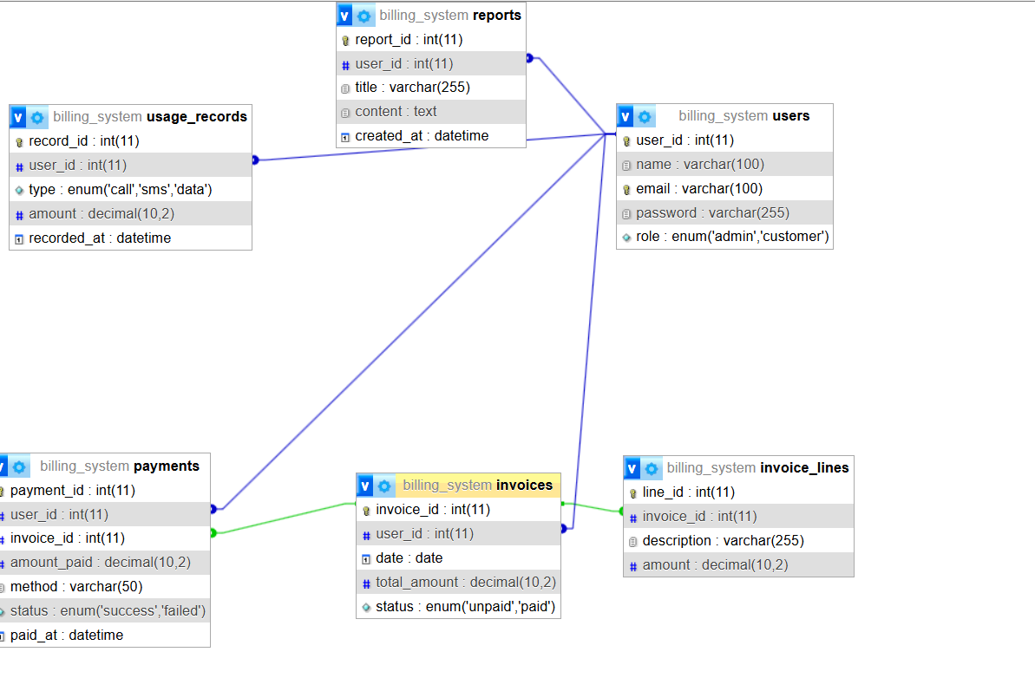

## Screenshots of your application

Use your Software Design Document to develop a functional business application. You need to include screenshots for your application in the SDD as evidence of using the preferred tools, techniques, and methodologies.

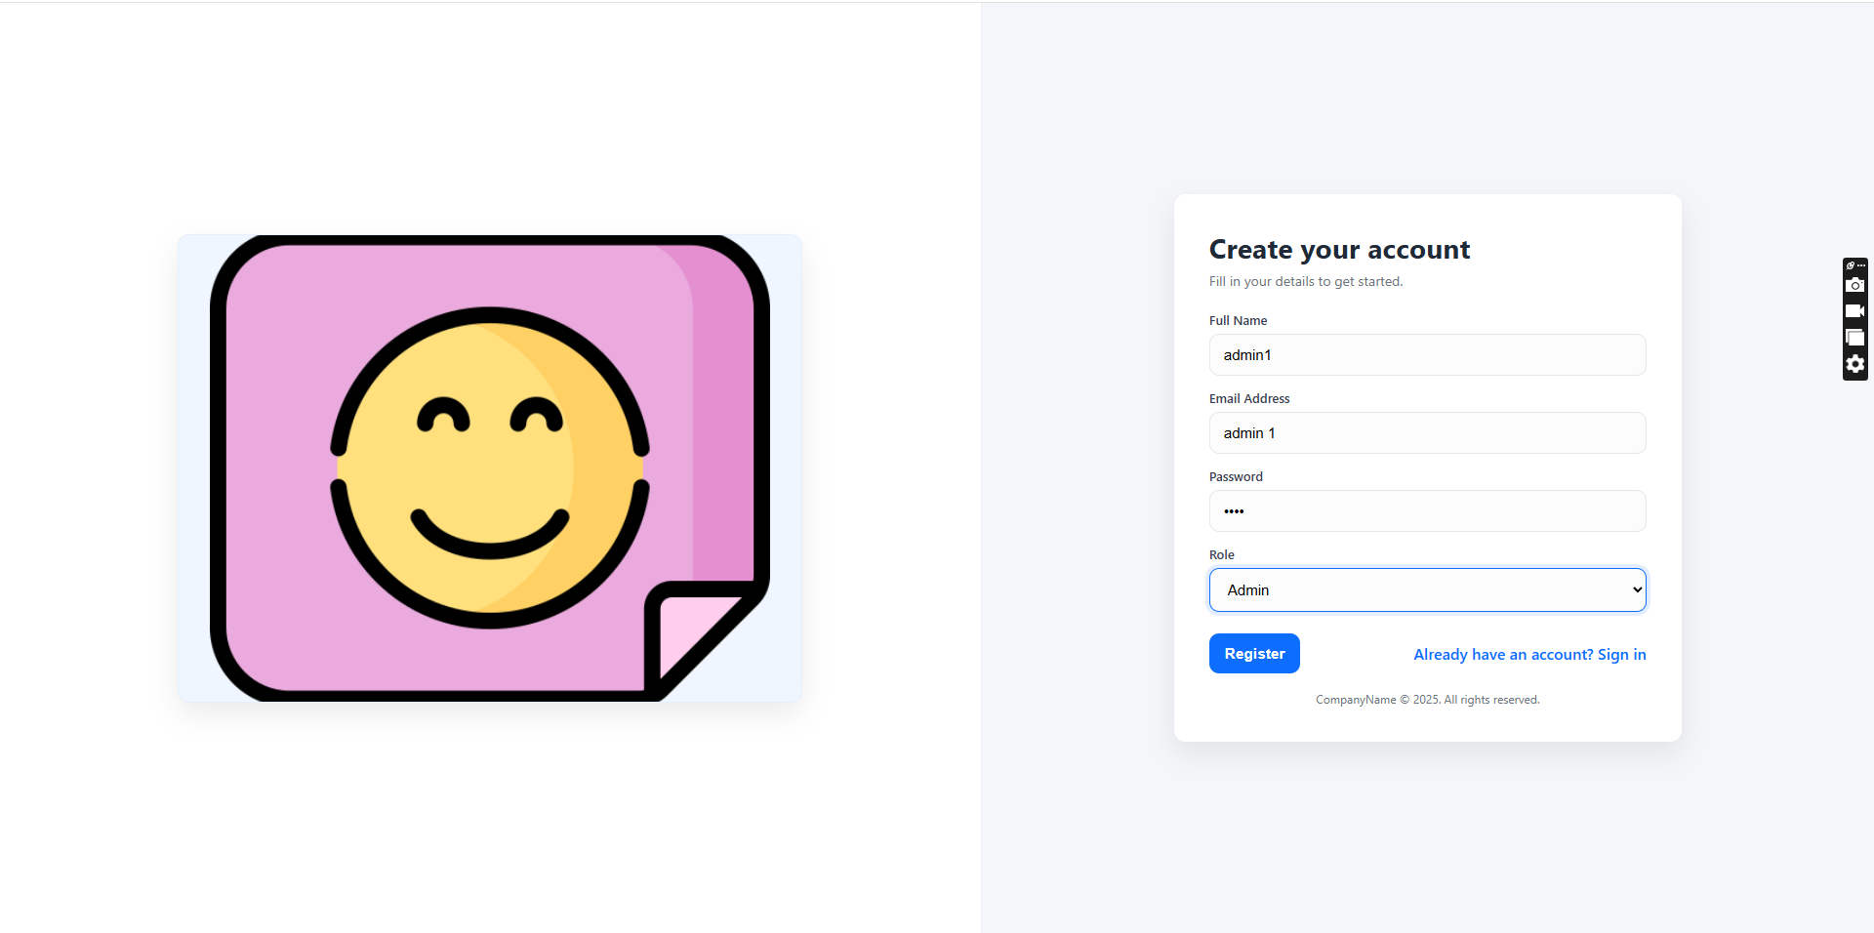



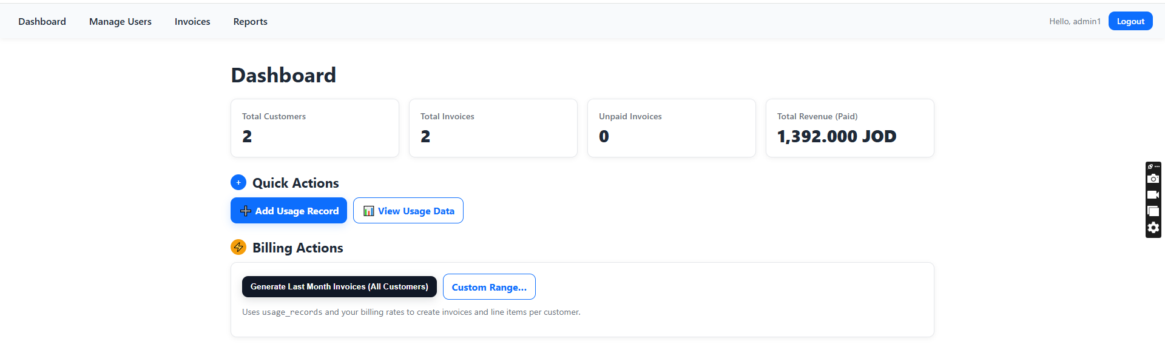

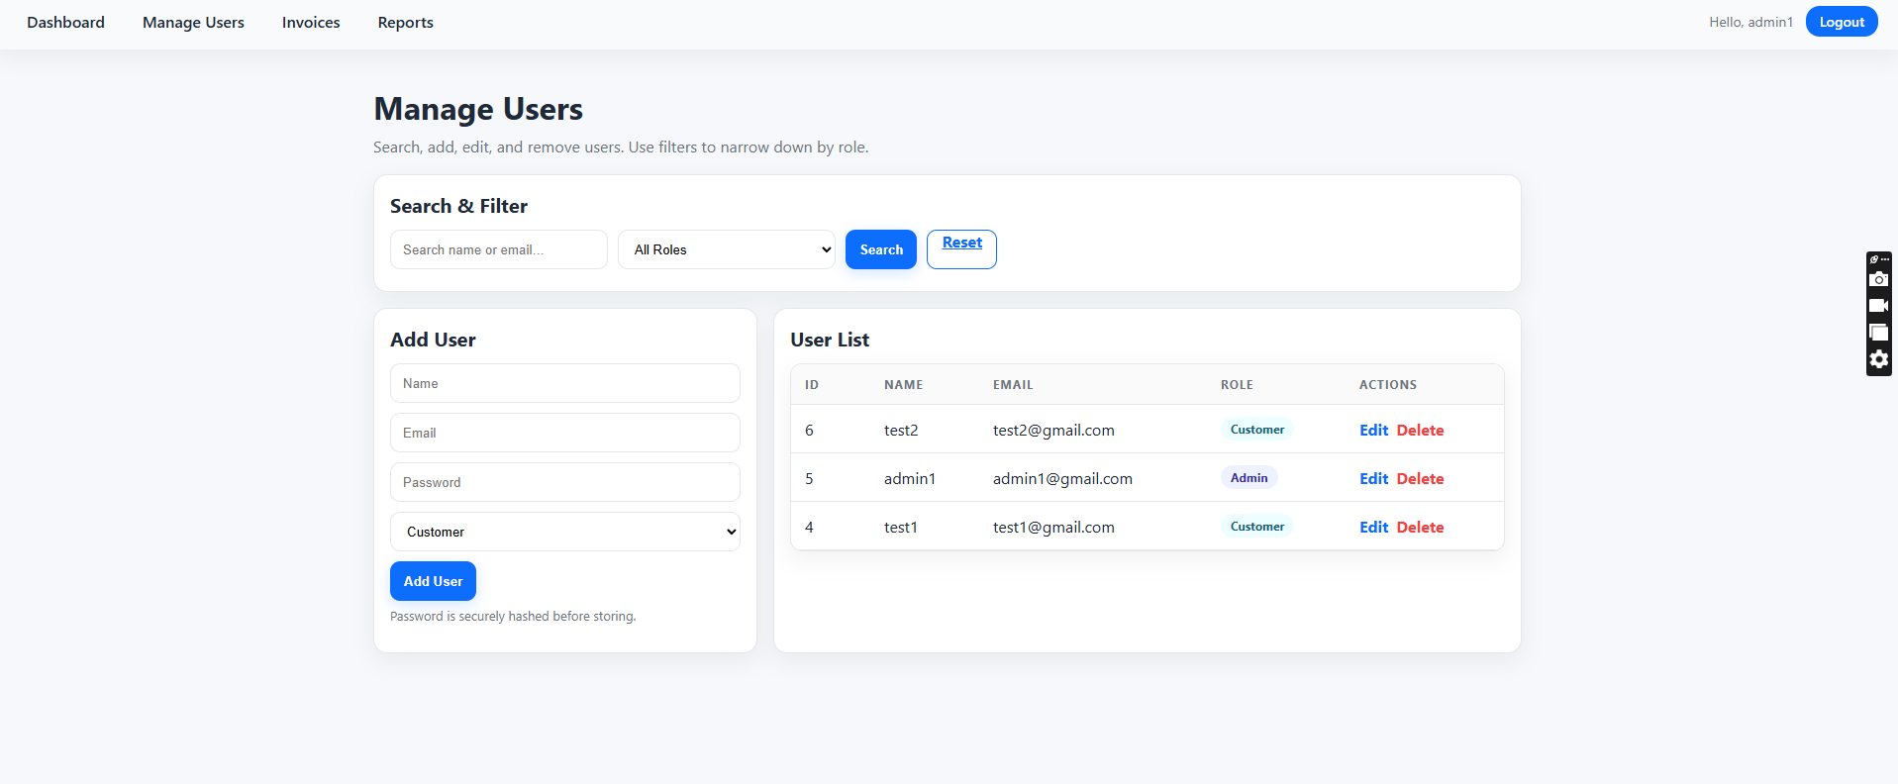

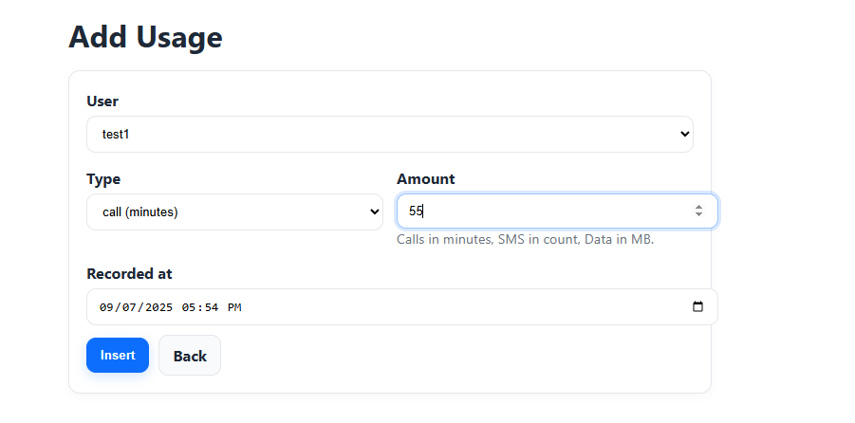

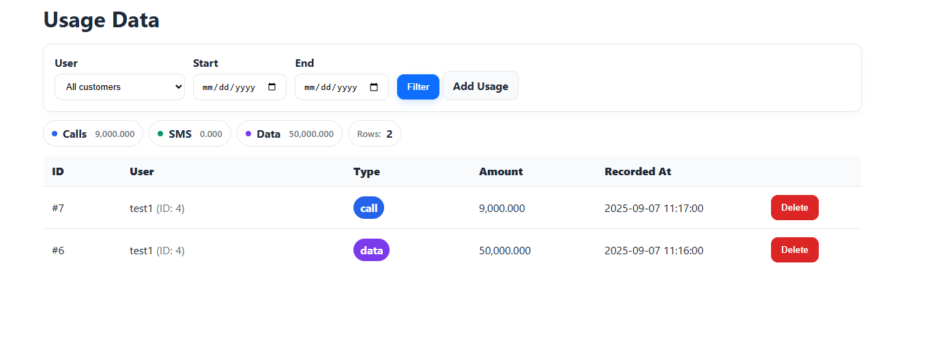

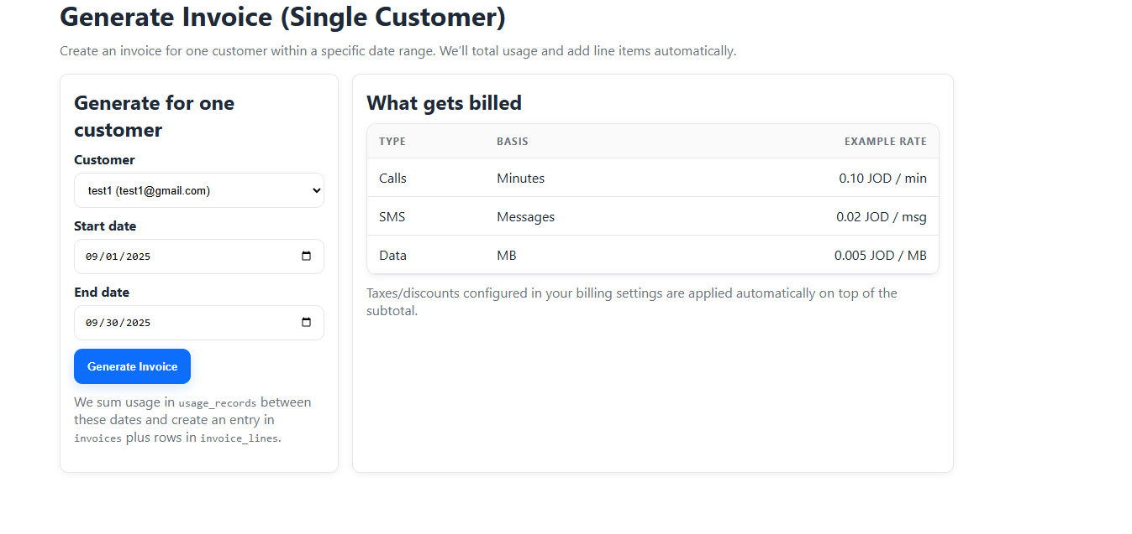

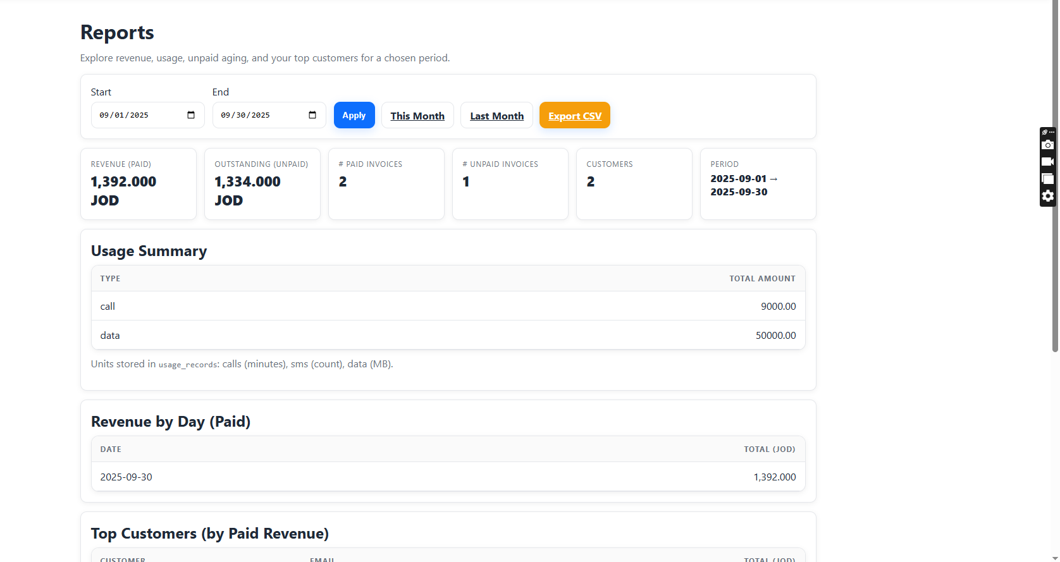

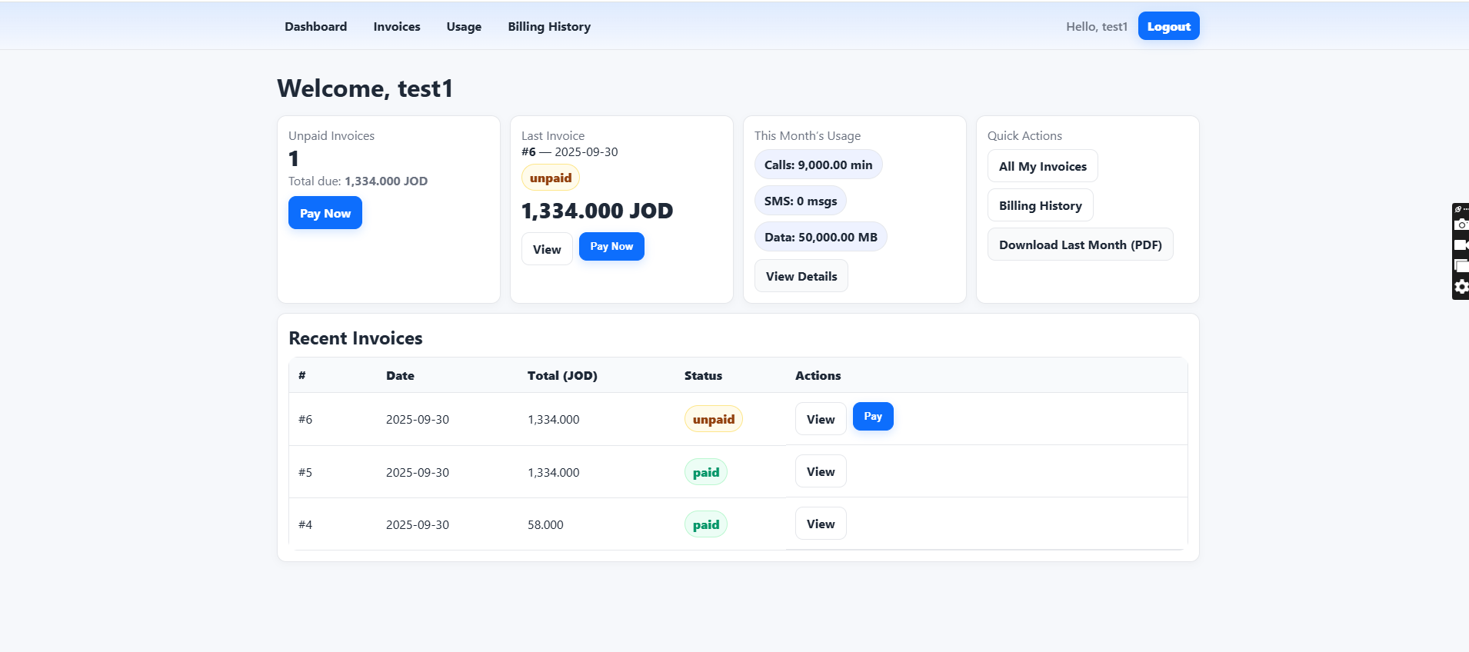

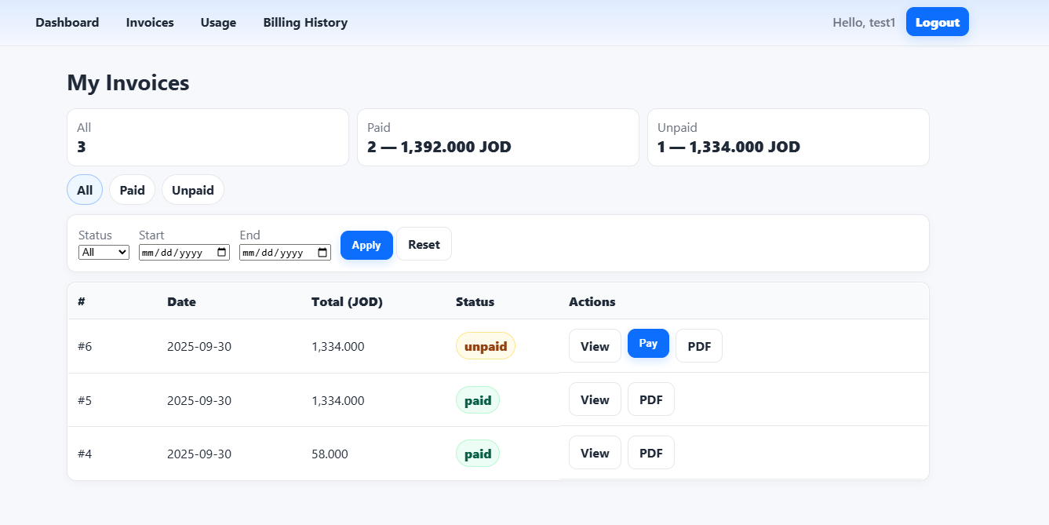

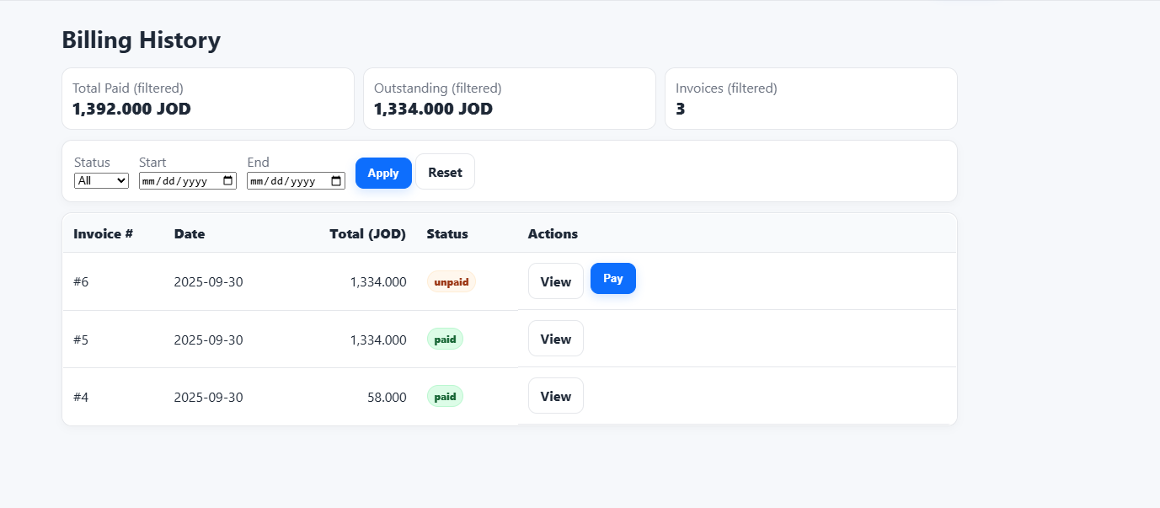

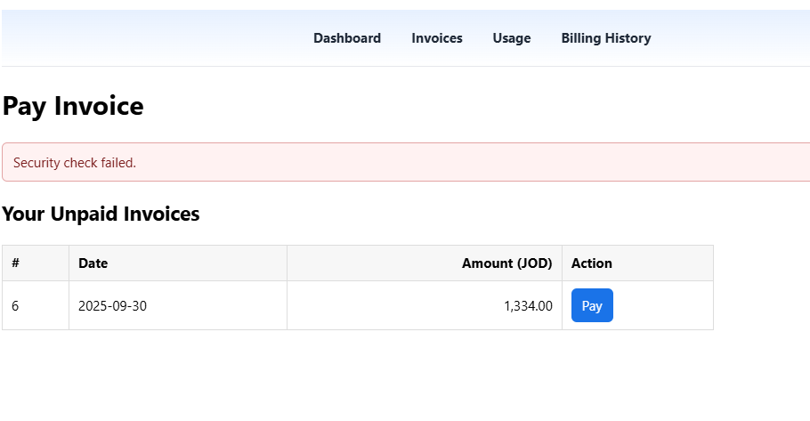

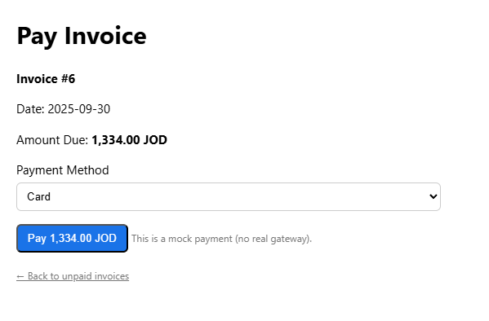

# Testing

## Testing plan

Research and use information relating to software testing to create a suitable test plan for your business application, in particular, you have to include at least 5 test cases for the system to be implemented.

**Note 1**: you need to test all the functionalities, UI, performance, integration, usability and database testcases in your application.

**Note 2:** for each test case you need to identify:

1. **Test ID** **and/or name:** a unique identifier that should follow a standard naming convention.
2. **Module name:** the module or feature under test.
3. **Test data**: this describes the dataset(s) to use for the test.
4. **Assumptions or preconditions**: describe the various steps that must be accomplished prior to testing, or what we can assume situationally about the test, such as “after a successful login.”
5. **Test priority:** define whether the test is low, medium or high priority.
6. **Test scenarios:** a high-level action from which the test case derives.
7. **Fill the below table:**

Table Test cases plan table

|  |  |  |  |  |  |
| --- | --- | --- | --- | --- | --- |
| Test id | Steps of Happy path | Steps of Alternative path | Steps of Exceptional path | Expected result | Actual result |
| TC01 | |  | | --- | |  |  |  | | --- | | user enters correct credentials and clicks **Login** | | user logs in with Remember Me cookie/session | user enters invalid username or password | |  | | --- | |  |  |  | | --- | | user is redirected to dashboard | | pass |
| TC02 | |  | | --- | |  |  |  | | --- | | user clicks Invoices, list of invoices loads | | user uses filter/search to find a specific invoice | |  | | --- | |  |  |  | | --- | | user tries to load invoices with expired session | | invoice list displayed correctly or filtered | pass |
| TC03 | user navigates to Usage tab and sees accurate usage | user applies a filter by type or date | user submits empty date filter or broken format | usage data displayed as per filter or alert shown | pass |
| TC04 | |  | | --- | |  |  |  |  |  | | --- | --- | --- | | |  | | --- | |  |  |  | | --- | | user fills all required fields (name, email, password) and submits | | | |  | | --- | |  |  |  | | --- | | user omits optional fields (e.g., phone number) and submits | | user enters already registered email or mismatched passwords | account is successfully created or proper error messages shown | pass |
| TC05 | |  | | --- | |  |  |  | | --- | | user sets valid date range and clicks apply | | user sets only a start date or only end date | user sets invalid date format (e.g., text instead of date) | filtered results shown or validation message appears | pass |
|  |  |  |  |  |  |

* TC01 – Login with Valid Credentials
* Module: Login & Authentication
* Test Data: A valid email and password combination (e.g., customer1@example.com, ValidPass123).
* Preconditions: The user account must already be registered and stored in the database.
* Priority: High
* Scenario: The user opens the login page, enters correct credentials, and expects to be redirected to their dashboard.
* TC02 – View Usage History
* Module: Usage Tracking
* Test Data: A customer account that has at least one call, SMS, or data session logged.
* Preconditions: User must be logged in, and usage records should exist in the database for that user.
* Priority: High
* Scenario: The user wants to review their past usage and expects accurate data to be shown in a table format.
* TC03 – Filter Billing History by Status
* Module: Billing Module
* Test Data: A list of invoices with mixed statuses (paid/unpaid).
* Preconditions: The user is logged in and has invoices already generated.
* Priority: High
* Scenario: User selects a filter (e.g., “Paid”) from a dropdown and expects only relevant records to appear.
* TC04 – Register New User
* Module: User Registration
* Test Data: A new name, email, and password that do not already exist in the system.
* Preconditions: The user is on the registration page and provides valid inputs.
* Priority: High
* Scenario: A visitor fills out the sign-up form and successfully creates a new customer account.
* TC05 – Filter Usage by Date
* Module: Usage History Filtering
* Test Data: A date range such as Jan 1, 2023 – Dec 31, 2023, with some usage records in that period.
* Preconditions: User is logged in and has sufficient usage data in the database.
* Priority: Medium
* Scenario: The user applies a date range to view usage only within the selected period.

## Performance review

Review the performance of your business application against the Problem Definition Statement and initial requirements by measuring the overall success of the application against your original prediction.

The developed billing and invoicing system performed exemplarily at addressing what was determined in the initial problem statement. The original goal of the completed project was to get rid of the human errors, delays, and inefficiencies created through the human components of manual billing. After implementing the system, we have seen significant improvements in all areas above. The ability for users to automatically generate invoices, track call and data usage in the present, and download PDFs for record situation removes the need to rely on frequently repeated human behaviour of manual tasking. The system also gives a clear, organized, and readable display of invoice history and usage logs, allowing billing information and records management to be even easier for both users and administrators. With central systems for tracking call usage, invoice history, billing invoice, billing information, and historical records. This method allowed us to avoid punitive measures due to replicated data and out-of-date billing information and allowed users to isolate trends or patterns for bill usage without the violence of retrieval and calendar delays. While the completed system does not contain the online payment piece required in the original problem statement, the system still resolved the major issues presented relate to billing transparency, consistency and the ability to reference previous transactions. Overall, the project produced the results expected and matched the initial requirements, indicating the design and development fell in line with the initial vision.

## Overall Business Application review

## Critical review for all application development phases

Analyse the factors that influence the performance of a business application and use them to undertake a critical review of the design, development and testing stages of your application. Conclude your review by reflectively discussing your previously identified risks.

Performance Influencing Factors

Performance is determined by several characteristics of the application(s), organizational systems, frameworks, state of code (quality), responsiveness (client side), efficiencies (server-side), and clarity of business logic. For our project, out technical foundations were based on HTML, CSS, JavaScript, and PHP. Our application's use of tools that met basic requirements somewhat aided loading speeds for everyone, decreased effects of latency, and simplified deployments. Our decision to not utilize an advanced or scalable framework (e.g. Laravel, React) are factors that could also restrict future scalability. The database interaction of the app was minimal and basic, allowing the underlying database to present speedier data fetching, but we suspect that with larger data sets, and depending on how much data was fetched on each page would require treatment hints like, indexing, or caching.

Design stage

During our design phase, we created wireframes and interface layouts that were representative of the needs described in the problem statement. Our user dashboard, invoice module, and usage tracking were fully mapped out prior to starting the app development process. The structure and design of the layout utilized repeatable design components (the cards, and tables) which allowed for the look of a clean UI, one issue we noted was that end-users if we did any UX testing or seeked opinions on a design from the end-users organization (mutable modifications). A better understanding of users needs and the design process could of caught any usability issues we missed during development.

Reflection of the Testing Stage

The testing phase included many test cases related to login, filtering invoices, tracking usage, and account registration. It used happy, alternative, and exceptional paths to ensure the application managed user actions as expected and in any unexpected way. Testing identified small bugs such as tricked date filters and PDF download edge cases, but they were handled quickly. However, testing was mostly human-based, without any automated parts or stress-testing, which are also sources of performance evaluation within a good testing phase. Adding tools, such as Selenium and Postman for automated testing, in the future will enhance this phase.

Reflection of the Risks

Some of the big risks identified in the identification phase included losing user data, slow server performance, and restricting the features as the technology stack is quite basic. Luckily, most of these risks never manifested through development or testing. The lightweight version of the application ensured stable performance. However, there was one risk we missed, which was no role-based access control. The current version has all users with equal access, which if this is used for business purposes might create a security risk. Moving forward, will need a plan for adding a form of access-control authentication and permissions.

Conclusion

In conclusion, while the application met its initial goals and relevant identified problems, there are still areas to be improved on, (in scaling, security, and testing.) The app was well designed, development was fluid on project scope (this led to fast development time), and testing covered major features and functions of the app. Overall, the project presented a finished MVP and has a solid basis to grow from if desired.

## Application evaluation and future development

Critically evaluate the strengths and weaknesses of your business application and fully justify opportunities for improvement and further development.

Application Strengths

A major strength of the application comes from its ease of use. The application has a clean, user-friendly interface that is easy to navigate, and users can reliably and confidently find their way through invoices, usage history, and billing summaries. This injection of simplicity and user-friendliness directly addresses one of the major inefficiencies and delays raised as part of the original problem statement. Additionally, HTML, CSS, JavaScript, and PHP provided a lightweight and efficient development process. As a result, aspects of the app like invoice filtering and real-time data display provide users with fast and responsive experiences that give confidence when managing billing activities to mitigate manual errors and faults. Another strength of the application is the introduction of the ability to add PDF generation and all filtering functions that improves record-keeping, tracking, and overall traceability.

Weaknesses of the Application

Although the application does have solid functionality, it does have some clear weaknesses. First, there is little to no attention to security which means there are no role-based access or authentication features that can be incorporated to better protect the web page if in a real-world application. Second, all the backend is just plain PHP which could risk maintainability, code re-use, and scalability as the application grows. Further, the user interface does not accommodate aptitude for mobile responsiveness or cross-browser tolerance to some degree. From a technical standpoint, it somewhat produces weaknesses in approach to not primarily use a framework e.g. Laravel or Bootstrap. From an overall coding perspective, the direct lack of a framework could slow the testing and development levels from the typical capacity if fully used. Ultimately, the time-consuming and manual testing that was completed could remove the consistent and thorough approach to testing an application via the automated scripts.

Opportunities for Improvement

There are many ways the application can be improved further. The biggest improvement would be to allow user authentication and role-based access control for users. This will allow the system to have secured login sessions and restrict user access based on roles and permissions (e.g. admin, finance team, general users). Conventions that come with a framework like Laravel help with routing, data validation, and security and as a bonus allow for better code organization and reusability if the repository is migrated to Git. On the front-end, using tools like Bootstrap or Tailwind CSS would make it easier to ensure UI consistency is maintained across different devices and improve the overall responsiveness of the site. Introducing automated testing like Selenium testing for the UI and PHPUnit testing for the backend will also ensure greater testing coverage and reduce the risk of missing a bug somewhere during an update/deployment.

To go beyond MVP, as an example, integrating a payment gateway could allow users to pay invoices online through their app. Additionally, adding a reporting dashboard and the option of data visualization could help clients better identify trends in their usage or costs over time. Another feature that would improve communication with clients is setting up an email notification and reminder for overdue invoices. Another long-term project could be to use the knowledge gained thus far to refactor the system to a multi-tenant SaaS platform. This would allow multiple companies to utilize the application via the same infrastructure and potentially provide a means for commercial deployment in the future.

# Implementation and support

Describe your implementation plan you may include user notification, user training, installation of hardware, installation of software onto production computers, and integration of the system into daily work processes. Also, describe your support and maintenance plan.

User Notification

Prior to the full deployment of the system, end-users will be notified by email messages or, in the case of larger groups, in-person briefing sessions. This communication will inform users of the impending system deployment, intended benefits, and the impact it will have on their day-to-day billing and usage tracking activities. The purpose of the communication and briefing session(s) is to alleviate any potential resistance to change and properly prepare the functional colleagues.

User Training

A short training program will be arranged to guide end-users (e.g., finance staff, administrators) through using the system. This training will include live demonstrations that have been pre-recorded, a user manual (in PDF format), and tutorial videos (in PDF format) explaining tasks such as invoice generation, filtering usage records, and exporting PDFs. The training will also include best practices and frequently asked questions to help with confusion after deployment.

Installation of Technology Devices and Equipment

There is no real new hardware to include in the project scope since it is an application for a browser and can run on any modern web browser. Internally, the performance of PCs being used by staff will be evaluated for minimum requirements (e.g., reasonably stable internet access, proper web browser access). If additional work is needed, we may need to perform updates to browsers and/or clean-up the systems.

Software Installation

The business application will be deployed to a production server, using PHP-compatible hosting with a MySQL Database. All dependencies such as PDF related libraries and database drivers will be pre-installed and tested on the server. The system may be hosted on a WAMP/XAMPP stack locally for internal testing only before moving onto the live hosting environment.

Integration into Daily Workflow

The system will eventually become integrated, starting with an introductory period. When the system launches, for the first week, the company will continue to use manual invoice methods for consistency in data for data integrity and to allow users to explore the new intake interface. At the conclusion of the first week, the manual system will be stopped. The new real-time tasks for finance and admin users will involve activities such as creating invoices, checking the usage and downloading transaction reports will be functions that have become second nature in their daily activities.

6.2. Support and Maintenance Plan

Technical Support

A dedicated technical support channel (e.g., a WhatsApp group?, email support, or support/helpdesk system) will be created for users to ask questions and report technical issues during the first month of use. Serious bugs that affect a majority of users, like a faulty server process, will be passed on to the developer for hotfixes when available. The expectation is that for typical or general issues, the staff will take no longer than 24 hours to respond, and staff will take no longer than 4–6 hours for urgent issues.

Bug Fixes and Updates

The forward-facing systems will be monitored for errors, usability issues, and performance issues. A bug tracking sheet will be provided, and bug fixes will be applied periodically via scheduled patches (e.g., once per week, during the first month alone). Feedback will be collected from users and improvements will be prioritized, analyzed, and rolled out incrementally.

Backups and Recovery

With respect to recovery from data loss, cron jobs will be scheduled to make daily database backups and these backups will be stored either in cloud storage or on an offsite physical drive. Full system backups will be taken weekly.

Planned Maintenance

A bi-weekly maintenance window (e.g., Fridays at 10 PM) will be designated for system maintenance, updates, database optimization, and system performance monitoring. Maintenance plan tasks may include clearing logs, updating PHP versions (when applicable), and evaluating improvements with respect to security measures (e.g., CAPTCHA, CSRF tokens).